Technical Inspection Report required by the Federal Court with the aim of providing grounds for the analysis of the Public Civil Action #5000325-94.2017.4.03.6135 being processed in the 25th Federal Civil Court of São Paulo.

Subject: Live Animals Export by sea, specifically, 27,800 oxes coming from the interior of Sao Paulo state, being boarded in the Port of Santos/SP (Brazil) with final destination, Turkey.

I, Magda Regina, CRMV-7583 (subscription under the Regional Council of Veterinary Medicine), make known that:

a) In January 31st of 2018, as soon as I received a subpoena issued by the above mentioned judge, by designation of which expressly authorized me to enter the ship named NADA (IMO 9005429, Panama flag) for the required technical inspection, I have appeared at the indicated place, at 8pm and made known to the port's operator representatives the injunction issued. At 11:30pm, two and a half hours after the presentation of the injunction and after waiting for its acknowledgement and compliance, the representative, who were initially delivered the court order on screen, returned it with no signs of protocol or formal acknowledgement, ignoring it and denying my access to the ship.

b) After several attempts to sustain a dialogue and requests for compliance with the aforementioned court order, I went to the Federal Police Station (Rua Riachuelo, 27 –
Centro, Santos) for a formal record of the noncompliance with the aforementioned court order.

c) On the next day, February 1st of 2018, I was contacted by phone (at 6am - over 12 hours after the court order) by the port's operator, authorizing me to enter the place where the inspection had been required. I informed the port's operator of the beginning of the inspection at 10am of the current day.

d) As soon as I entered the ship NADA (ship containing 13 floors occupied by stalls (or cattle crushes) to accommodate thousands of animals), I climbed one flight of stairs and was led to a meeting room to talk with representatives of the several stakeholders of this enterprise, namelly, the imports/exports company Ecoporto, Companhia Docas do Estado de São Paulo (Codesp), the Ministry of Agriculture, Livestock and Food Supply (MAPA), Minerva Foods S.A. and members of the ship crew, when they briefly described the animals management routine, their feeding and the cleaning process of the pens where the calves are confined.

d.1) It is worth adding that the boarding operation at the NADA ship began on January 26 (Monday) and lasted up to January 31, certainly until 11:30pm (Wednesday), when I was notified that the entering of trucks bringing animals to the Port of Santos had been halted. The trucks bringing animals from the quarantine zone (Pre-Boarding Station - EPE), located 500km from the Port of Santos (in the cities of Altinopolis and Sabino) were loaded with 27 to 38 animals per container, upright; the containers had their lateral orifices sealed with tape to hinder visibility aiming at impeding inspection (observation, recording, photographing) of its interior by a third part.

d.2) the number of animals described was verified after a blitz operation in which I was actively involved as a veterinary working for the Government of the city of Santos on the days that the trucks arrived at the port with the animals. During this blitz operation the departure time of the animals from the Pre-Boarding Station (EPE) and the time of their arrival at the location of the blitz at the entrance of the Port of Santos were checked. The length of the journey was assessed as varying from 8-14 hours; the amount of urine and feces produced throughout their journey inside the containers being noteworthy, as well as feces and urine thrown along public roads. During the inspection (blitz) I observed several prostrated animals inside the containers and, although the number of animals was in agreement with MAPA guidelines (Ministry of Agriculture, Livestock, and Supply), animals were not able to move or turn around in their narrow confinement spaces.
e) After the meeting mentioned in item (d), I was led to inspect an animal confinement floor on the same level as the meeting (8th floor). This floor (also known as deck) has side windows and is above the bootop of the ship. In this area animal conditions of light, ventilation, and space were apparently moderate. The floor was covered in rice husk (in order to mitigate animals slipping on wet floor), there was sporadic side ventilation, and troughs showed modest amounts of food and water. During the meeting with the crew I was reported that the ship contained its own desalinization system for ocean water, however it remains disconnected when the ship is docked, therefore requiring water supplies from outside. I was able to notice a clear interest in restricting my inspection to that level. I requested a visit to the lower floors of the ship; at this point I was warned that the cleaning procedures on these floors were facing operational problems.
f) After going to the lower floors (decks 1, 2 and 5) I confirmed that cleaning conditions were very precarious – notably for the animals in the ship since the 26th of January (7 days before the inspection). The enormous amount of urine and feces accumulated during this period led to an impressive layer of muddy feces. The smell of ammonia was extremely intense, making it hard to breathe. On some of the floors the artificial ventilation system tried to mitigate the effect of gases and odors accumulated, which also resulted from the decomposition of bovine organic matter. Sound pollution (in decibels) resulting from the constant use of fans was intense and clearly inopportune. As reported by the veterinary on board who accompanied me during the inspection, the time consumed during the animals boarding operations makes it so that the lower floors, occupied primarily, are more precarious in terms of sanitation due to the impossibility of washing the floors. Floors are washed every 5 days, but only after the departure of the ship, as informed by a technical member of the crew. Floors are washed with a low-pressure water jet by a wide hose, leading the materials to a storage tank (not inspected). The slurry accumulated in the cleaning process is then discarded, untreated, into the ocean. The slurry is discarded periodically, depending on the speed of the ship.
g) In a specific sector of the ship, known as ‘Graxaria’ (‘grease area’), I observed a piece of equipment used to grind dead animals; the ground material is also thrown into the ocean. I was informed that the veterinary team on board varies from one (01) to three (03), assisted by a total of (08) cowboys working in shifts, assessing the animals’ condition throughout the days. This equals to saying that with three veterinaries on board in charge of medical assistance and inspection we would have one vet for every 9000 confined animals.
After this brief report, here follow the answers to the questions in the Court Ruling:

Questions:

1.) What is the purpose of the Brazilian export of live animals? Are they for slaughter for human consumption, or for other purposes (such as religious rituals)?
According to the spokespeople for Minerva Foods S.A. (owners of the live haul for sale sent for shipping), the veterinary on board and the Commanding Officer, I was informed that all animals were destined to slaughter for human consumption. According to the Turkish religious tradition, animals can only be slaughtered after the second permanent tooth shows –after that moment, the animal may be slaughtered (in this case, the calf). Before that, the animal is considered juvenile, and therefore not subject to aggression.

2.) How are the animals transported abroad accommodated in trucks or ships destined to slaughter in other countries?

In the trucks, as mentioned before, during the inspections organized by the city hall of Santos, of which I have participated actively as a veterinarian and permanent civil servant, the animals were accommodated in the rear part of the vehicles, in numbers varying between 27 and 38 animals per truck. The lateral orifices of the containers had been sealed with tape aiming at impeding inspection of third parties. Once confined inside the vehicles with the seal administered by MAPA (the ministry of agriculture), the animals faced 8 to 14 hours of travel. Several trucks were equipped with metal tip sticks connected to the vehicles electrical system, with the purpose of preventing the animals from lying down on the vehicles floor by means of electrical shocks. In the ships, it is known that the animals are coerced to enter the lower floors with electrical shock until reaching the maximum or predetermined capacity. The animals are placed in groups (in stalls or cattle crushes), in narrow spaces, totalizing, for instance, areas smaller than 1m² per individual. In the trucks as well as in the stalls inside the ships, the movement of the animals is seriously compromised. In the stalls with intact animals (non-neutered calves), the mount behavior is commonly observed, i.e, animals mounting each other as a clear exhibition of dominance, reducing the space available for the animals in their surrounding when they lay down on the floor - this increases the incidence of falls and similar accidents. Production of excrements (feces and urine) by the animals in these enclosed environments exposes them, intimately and constantly, to a scenario of intense insalubrity.

3.) As they are transported, are the animals able to change position or, given the density space/head, is the animal forced to stay in the same position during the entire trip? Do the transport conditions favor the incidence of trauma, either because of the density space/head or the nature/duration of the transport?

I reinforce that in the trucks there is absolutely no possibility for the animal to change position once it is boarded. In the ship, although there is a minimal mobility in some cattle crushes, if the capacity is not extrapolated, general mobility is also severely reduced and/or compromised. Since it is a large maritime vehicle, subjected to intrinsic and natural oscillations of the ocean currents, pendulum movements of the ship may lead to unbalance (since the animals are terrestrial by nature), resulting in traumatic accidents and serious physiologic discomfort.

4.) Throughout the travel, is there regular supply of food and water? Are there feeder and drinking equipment installed? In what hygienic-sanitary condition? Is there room for rest?
Yes, there is regular supply of food given that the animals weight is a determining factor in its commercial value. However in regards to the water supply, during the period the ship is moored (that is, docked), water provision is outsourced given that its desalinization system is disconnected. Once departed this ship (not necessarily all of them) is able to produce sufficient drinking water. The treated water is used for consumption as well as cleaning operations in the rooms crowded with animals. Feeder and drinking equipment are available in the animals’ enclosure – several presenting stool debris and clear patches of rust. Definitely live animals sea transportation does not contemplate the possibility for the livestock to exit their confinement stalls until arrival at destination, thus impeding any kind of rest or stroll for the animal. Inside its enclosure (stalls) the only possible movement is prostration on the floor. Such movement certainly reduces space usage in the area of neighboring animals in the same cattle crush and thus subjects the animal to intimate contact with its own stool and that of other animals.
5.) Do the ships present adequate temperature and humidity ventilation and/or exhaustion systems?
The commercial variety of vessels destined to live animals transportation is broad. In this sense, ventilation and exhaustion mechanisms vary in project and efficiency. In this particular case the ship performs ventilation and exhaustion of the lower floors causing severe sound pollution and assuring incomplete circulation and renewal of the gases thereby. It follows from this observation the registry of high temperature in these rooms as well as extreme humidity rates that clearly compromise animal welfare.
6.) Are the animal storage structures of these ships adequate for transport? Is the surface slippery? Are there risks for animal injuries?
These ships’ structures are not adequate for this purpose. As an example the vessel NADA, built in 1993, was adapted in 2012 in China from a craft specialized in container transport. Therefore it was not planned and built aiming at animal transportation. The whole structure of these ships is metal, including floors and partitions. One can notice how the floors become extremely slippery in the presence of large amounts of stool and urine – which is the rule. Therefore yes, the risks of accidents for the animals are extremely high.
7.) During transport are any measures taken that ensure the welfare of these animals?
Absolutely not. The transport of animals for long periods of time and distance, be it by land or sea, subjects these organisms to an experience completely alien to its original nature. The insalubrity to which they are exposed, the movement of the vehicles (such as braking, swinging, shifts of speed and sudden maneuvers), the prolonged confinement, the food and water restrictions etc. all preclude the assurance of animal welfare in its most basic sense.
8.) During transport are there any veterinaries on sight? Are animal casualties often checked for? In case of animal casualty, what measures are taken? And in case of disease?
Yes. However, given the enormous hardship of managing clinical intercurrences in large herds, the number of veterinary professionals, even if high, would not prevent these problems. The casualty of animals is inextricably bound to the practice of live animals sea transportation. Whenever death occurs the corpses are taken to the Graxaria (‘grease area’) and inserted in a mechanical device that grinds them completely. The pieces of carcass are gathered and discarded en route. Whenever sick animals are identified they are treated with medicines found on the ship’s veterinary farmacy and, in specific cases, removed from their stalls and isolated in a pre-determined area. Handling these animals, removing them from their original stalls and conducing to treatment areas, is a costly and laborious task, occurring infrequently.
9.) Is this transport inspected by governmental authorities?
Yes, but inspection is limited to some representatives of MAPA (Ministry of Agriculture, Livestock and Food Supply).
10.) In the countries to which the animals are sent (or in the least for the main importers) what kind of slaughter is performed?
For countries with Muslim tradition: Halial slaughter (meaning “allowed”). In this practice of halal slaughter the knife must be very sharp and inflict a single bleeding of the animal. The cut must hit the trachea, the esophagus, arteries and the jugular vein, so that all the blood is drained from the animal. For countries with Jewish tradition: coser slaughter (meaning “proper”). Kosher slaughter follows a similar procedure to halal. Here the knife’s edge may not touch the cervical vertebrae and if after beheading any sign of slot or tooth is observed the animal is considered improper or non-kosher (terayfa), being thus discarded.
About the five freedoms
The five freedoms are a world-class parameter for diagnosing the spectrum of animal welfare and include important aspects that influence animal’s quality of life. This principle is recognized and endorsed by the Federal Council of Veterinary Medicine (CFMV). They are: (1) the freedom from thirst, hunger and malnutrition; (2) freedom from pain and disease; (3) freedom from discomfort; (4) freedom to express the specie’s natural behavior; (5) freedom from fear and stress.
The Five Freedoms recommended by the CFMV are all impaired in the process of live animal sea transport in the following manner:
Freedom from thirst, hunger and malnutrition
Water and food restrictions are easily observed from the beginning of road transport, extended and amplified during confinement in the sea vessel stalls. Water shortage and high probability of contamination in the food provided are clear examples of violation of this freedom.
Freedom from pain and disease
The extreme insalubrity of the enclosures, contamination of the daily input doses, accidents following transport procedures (land and sea), restriction in mobility and space, extreme concentration of gases, long lasting environmental changes are some of the examples that result from this process.
Freedom from discomfort
Animals prostrated over feces and urine (their own and that of other animals), extreme deprivation of space, nonexistent body hygiene, constant lighting during travel beyond the day/night seasonality.
Freedom to express the specie’s natural behavior
Land animals being forced into road and sea transport in slippery, insanitary floors for long distances. Crowding in narrow spaces with high population density and mixing of animal flocks (different races).
Freedom from fear and stress
Fear, stress and other ethological change are natural and evident consequences of exposure to the events previously mentioned in this report.
Final considerations
Based on the aforementioned facts, observed by means of entry and inspection of a sea vessel intended for the confinement and transport of live animals for long distances for rearing, fattening and slaughter abroad, I am of the opinion that indicatives abound attesting animal abuse and explicit violation of animal dignity. In addition elementary reasonability criteria were exceeded and the five freedoms attesting animal welfare were all violated.
I understand therefore that the practice of sea transport of live animals for long distances is intrinsically and inherently related to the infliction of cruelty, suffering, pain, indignity and corruption of animal welfare in various forms.
It is the report.
February 2nd, 2018

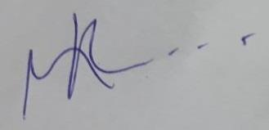

Magda Regina – CRMV 7583
RG 15219110

---------------XXX-------------
Images (& videos)
The images here enclosed were registered in Brazilian territory (Santos/SP) inside the vessel NADA in February 1st, 2018. Those responsible for the commercialization of the animals begun boarding the thousands of livestock in January 26h, 2018 and the ship is docked in the Port of Santos. The evidences of insalubrity here presented are samples of a ship that has not even started its intercontinental travel that will last a minimum of 15 days.

Visitation area (showroom)
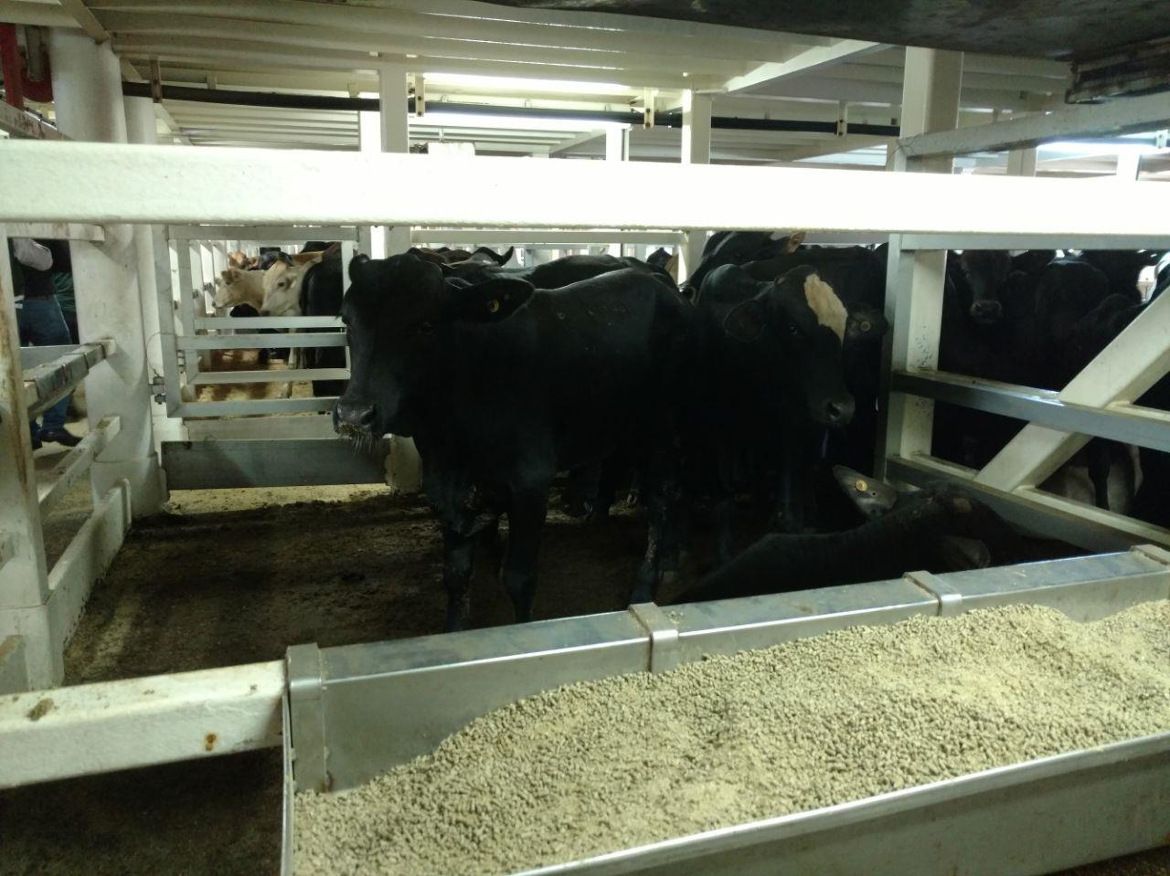
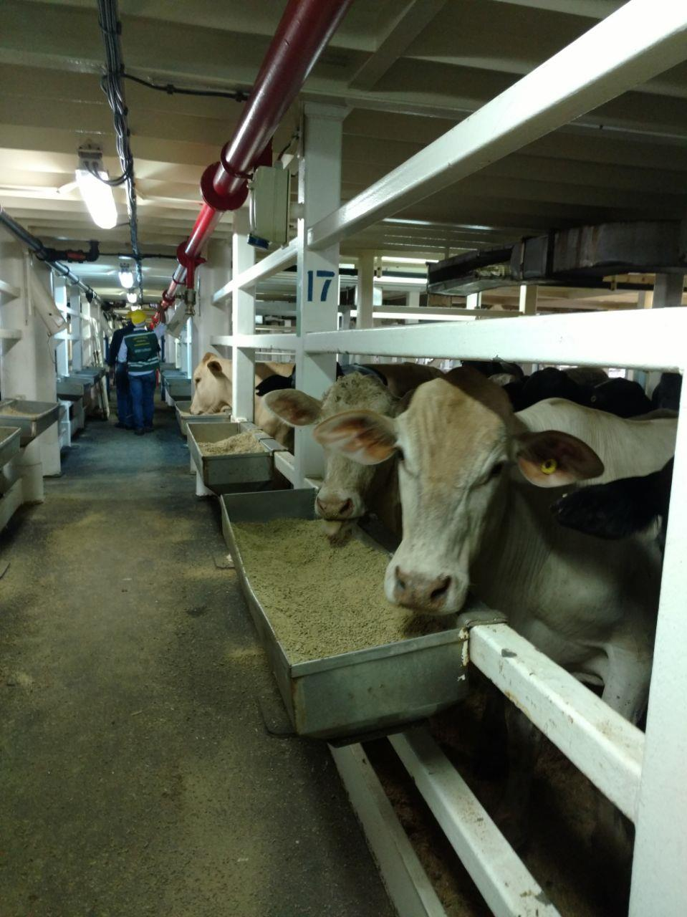
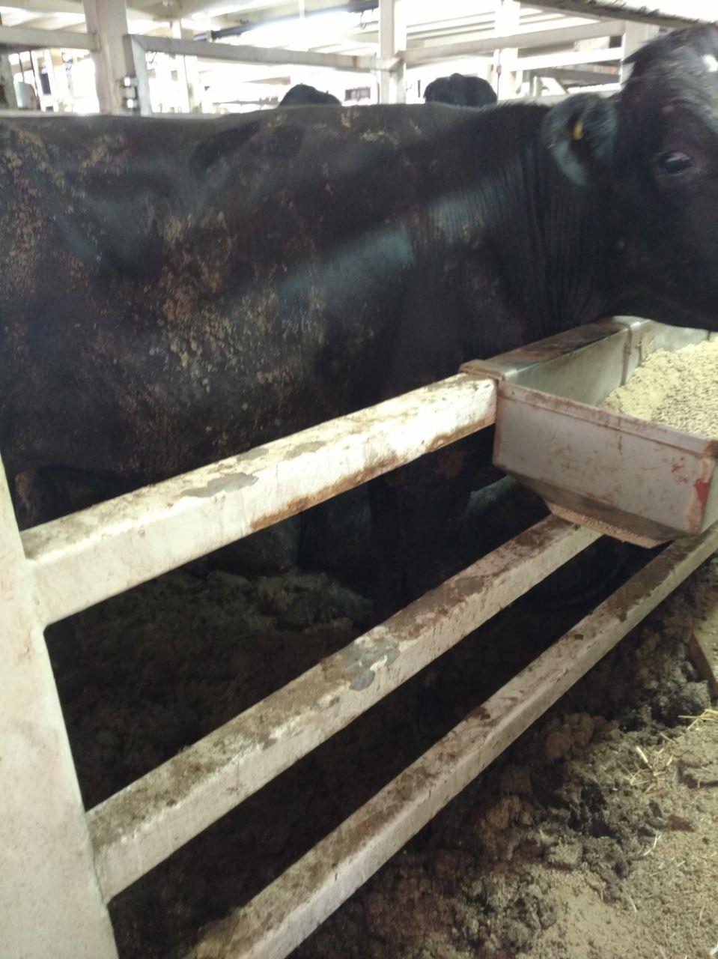
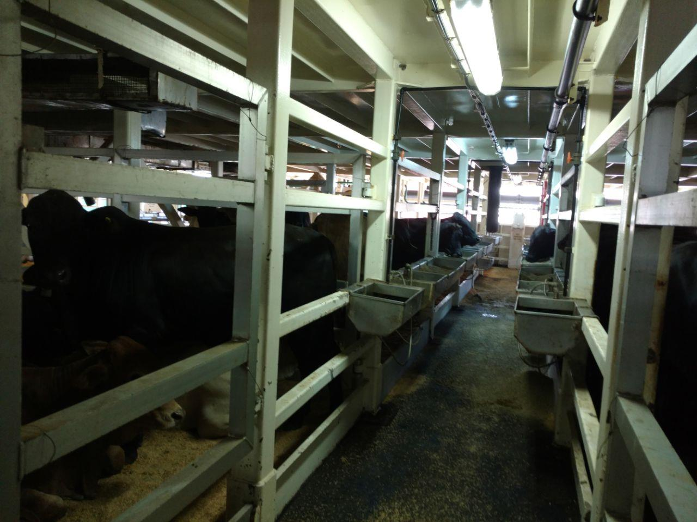
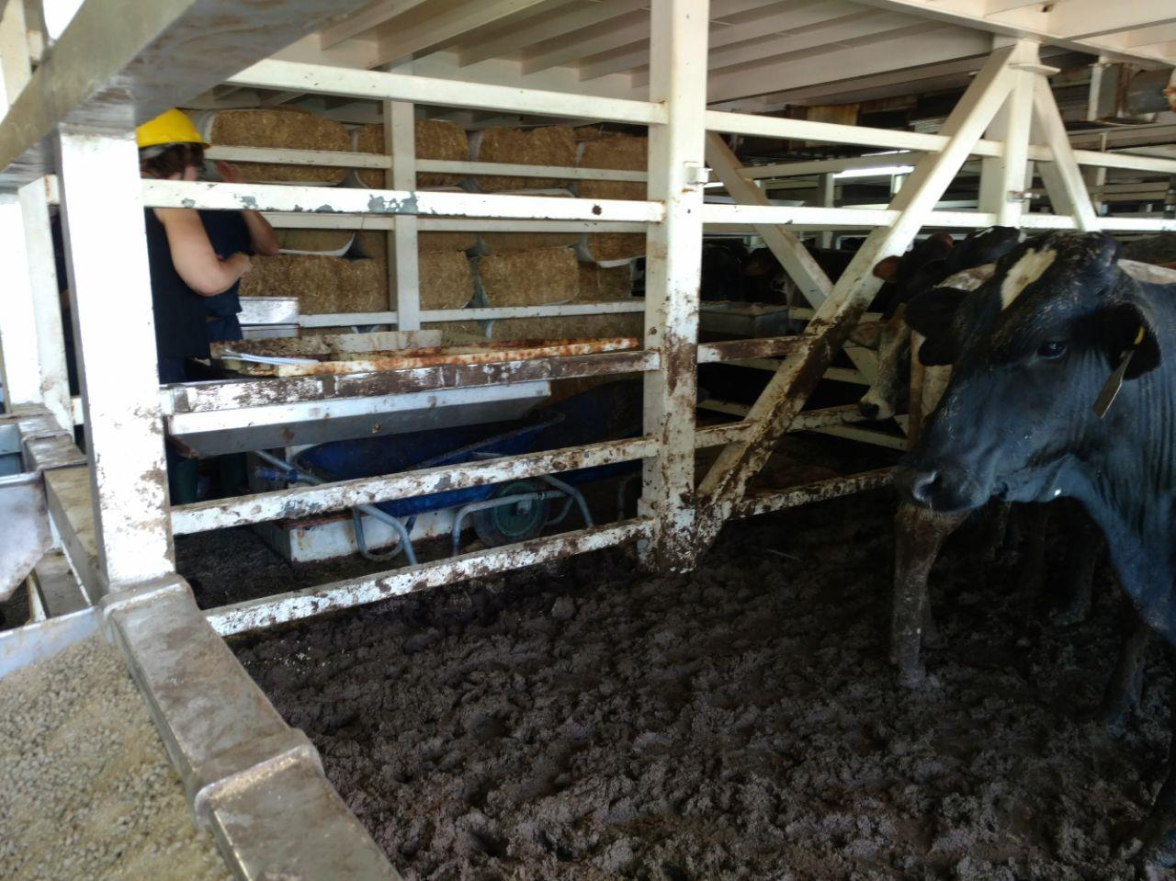
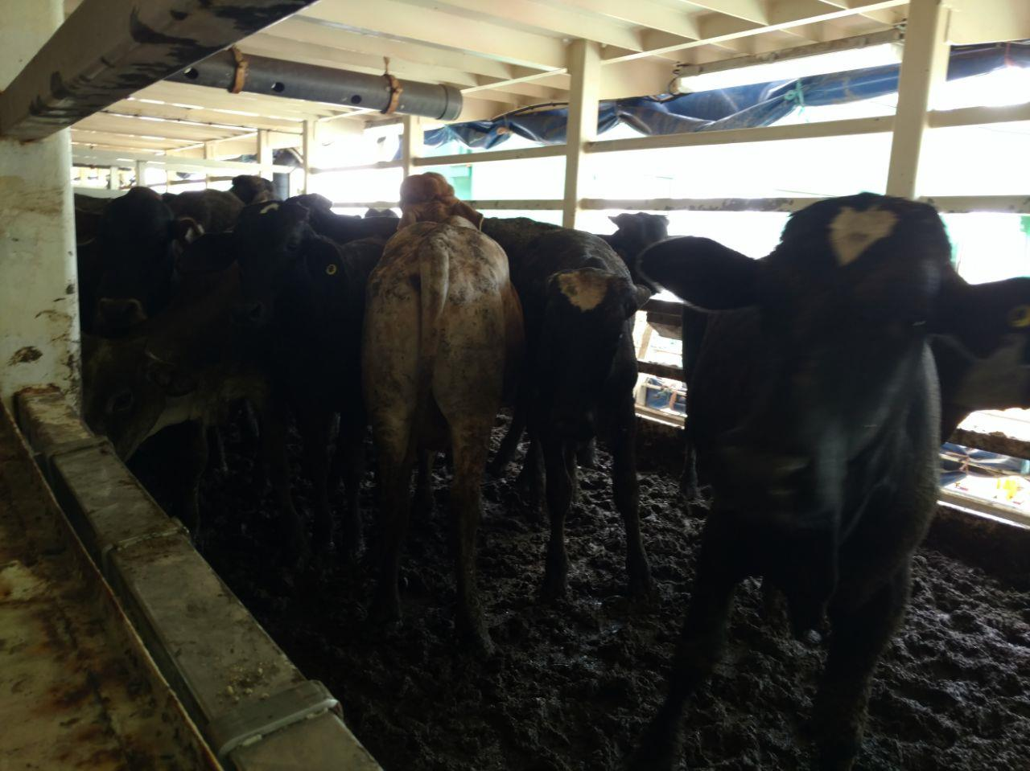
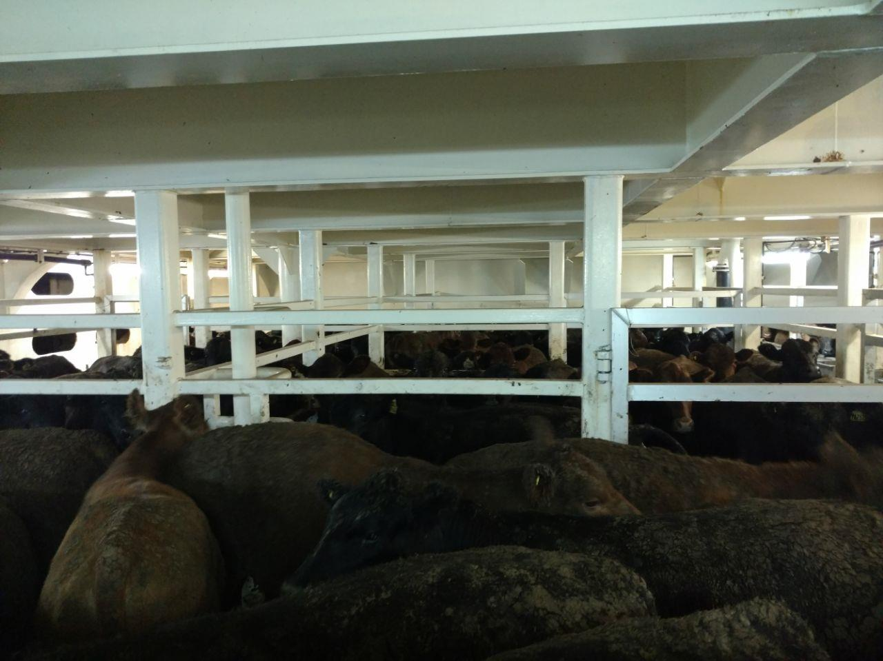
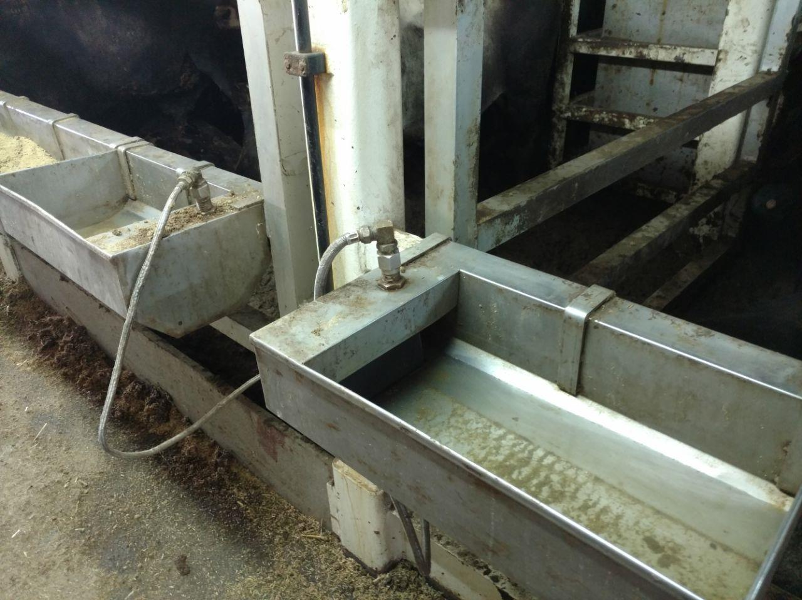
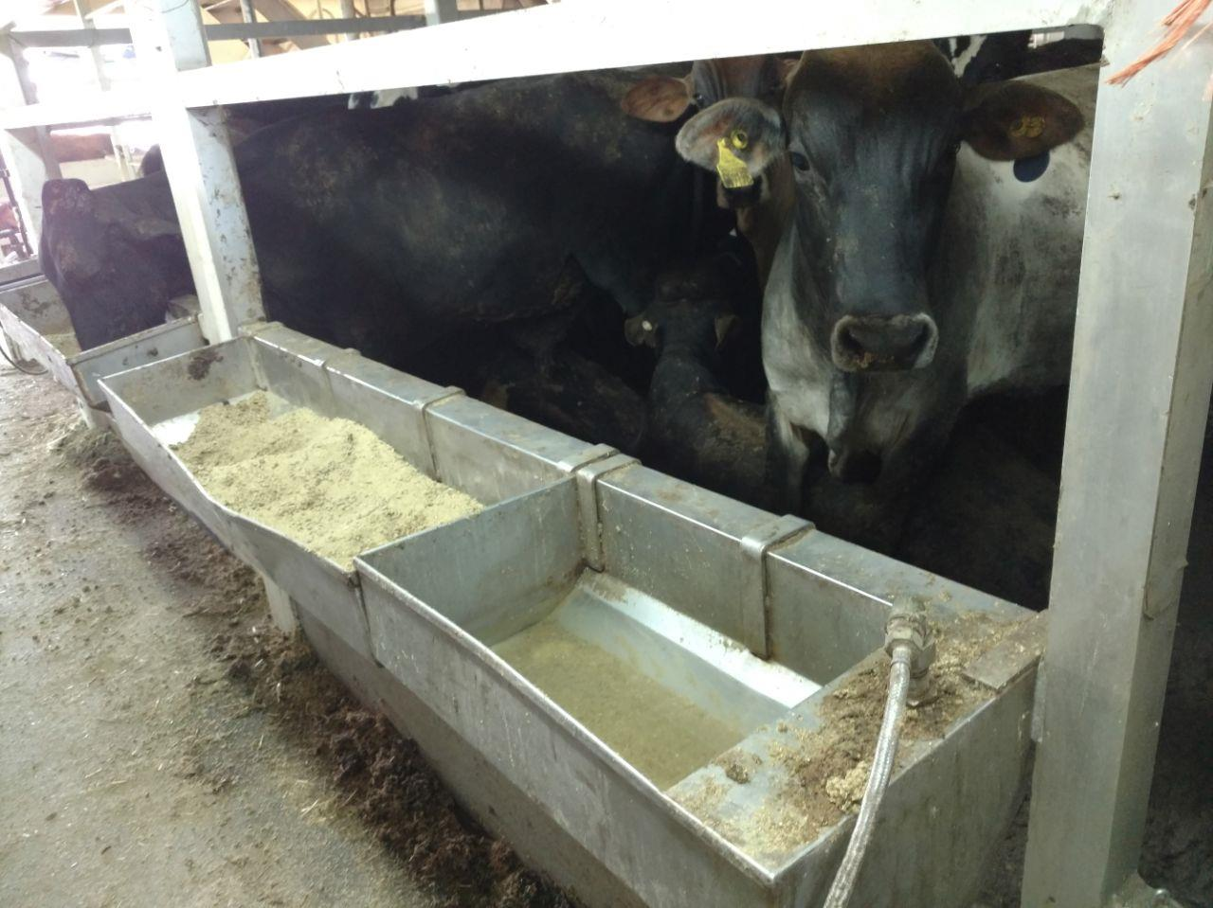
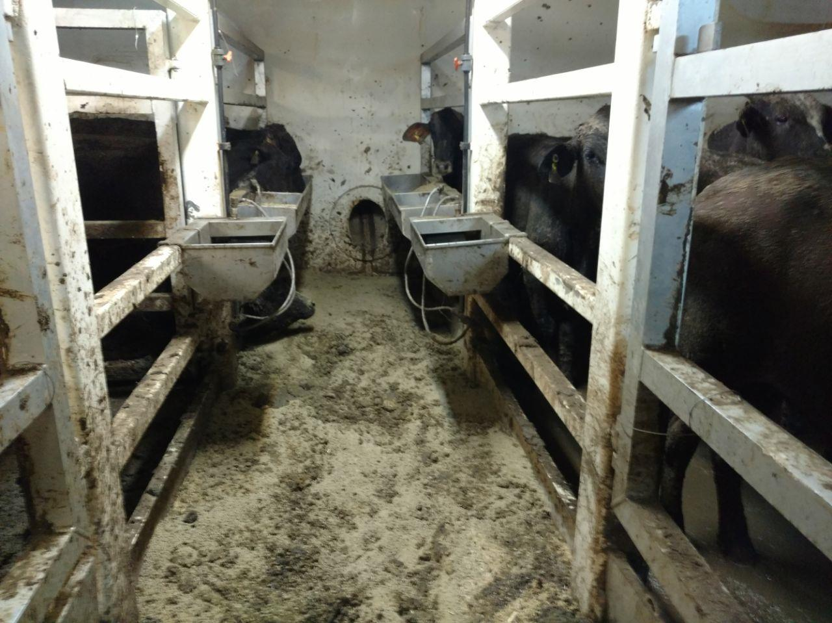

Stall dimensions – usually occupied by more that 21 animals (i.e. less than 1m² per animal) 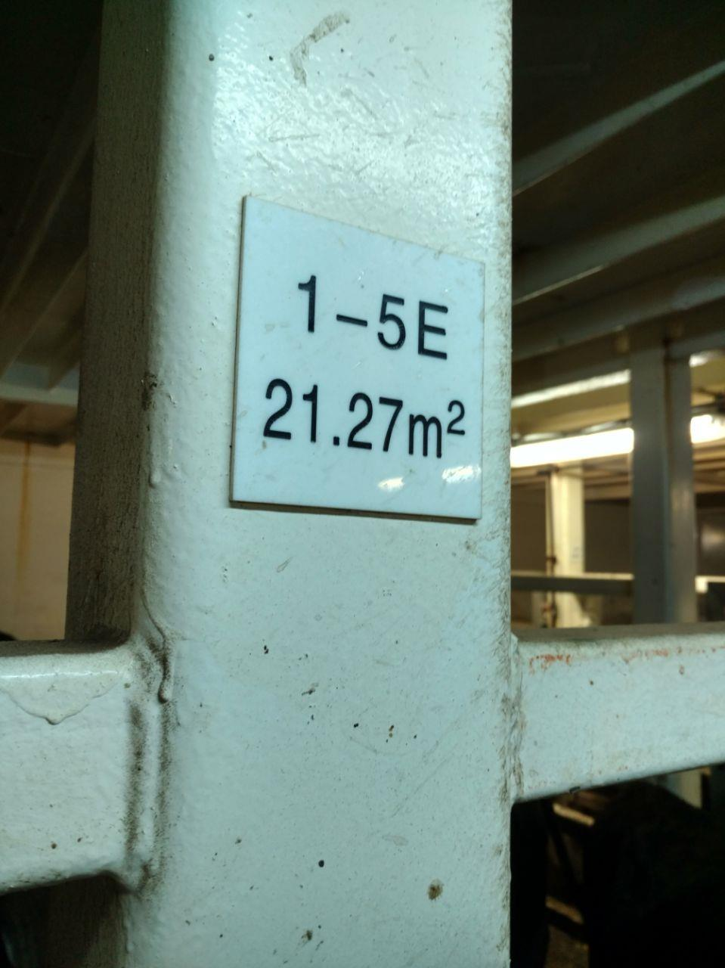
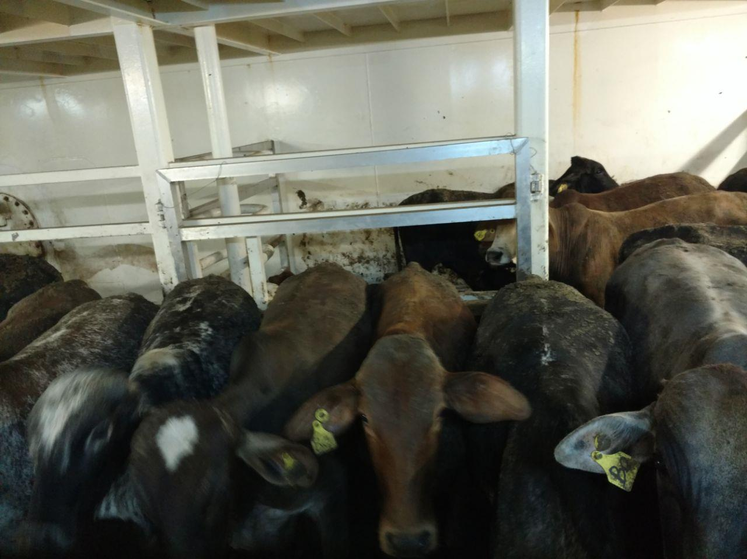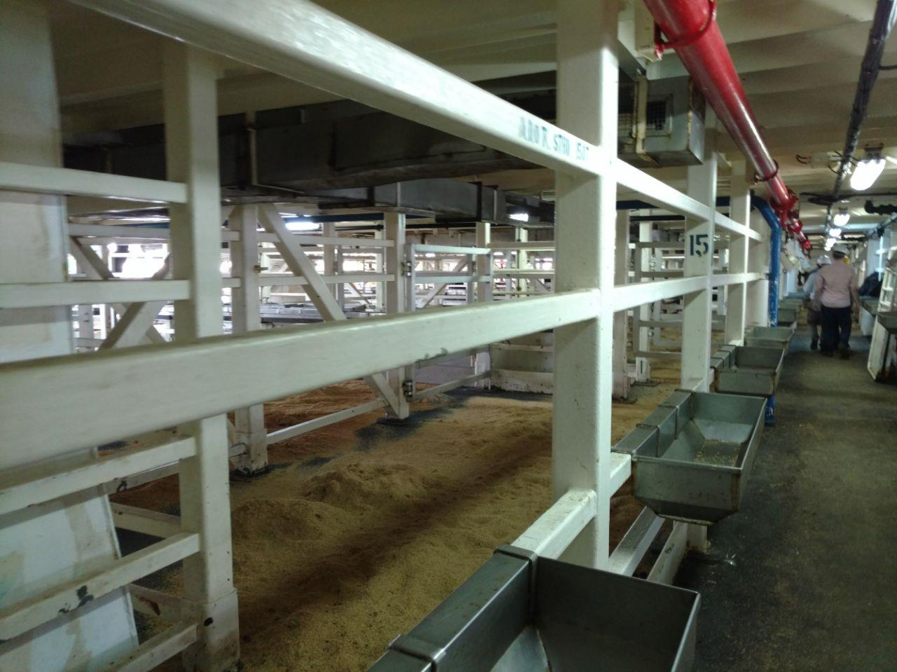

Area restricted to crew (lower floors)
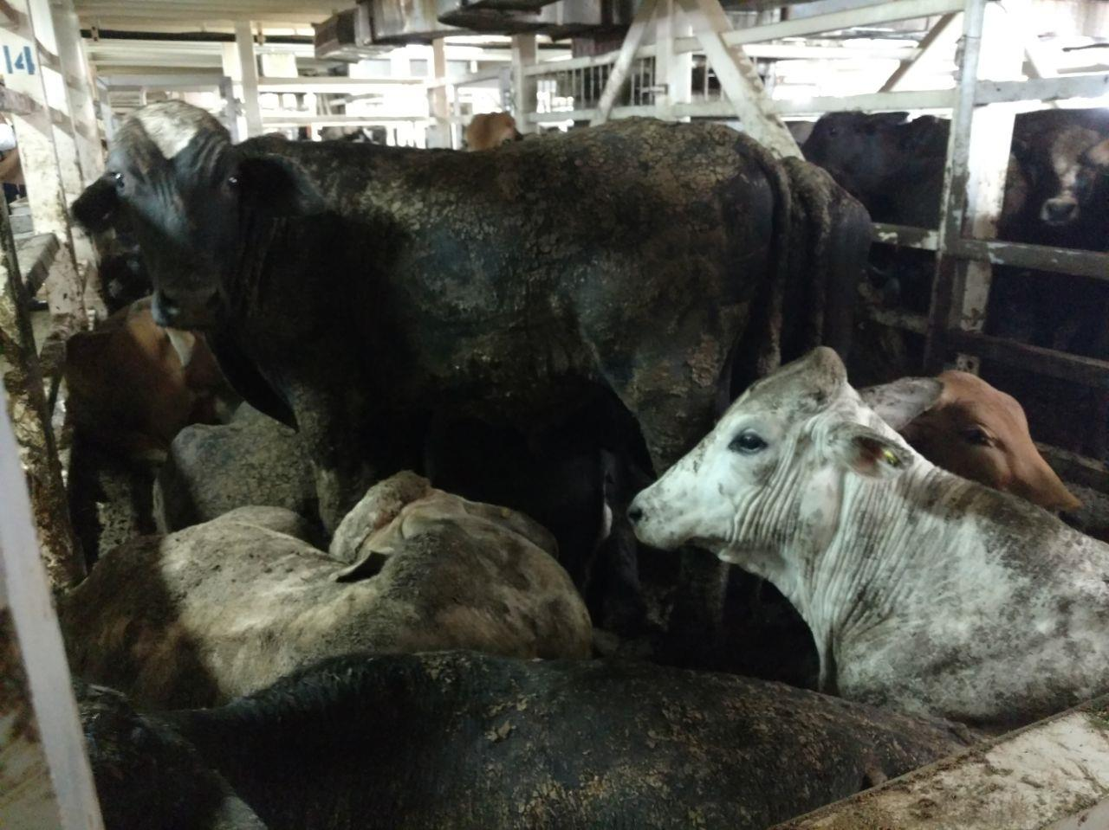
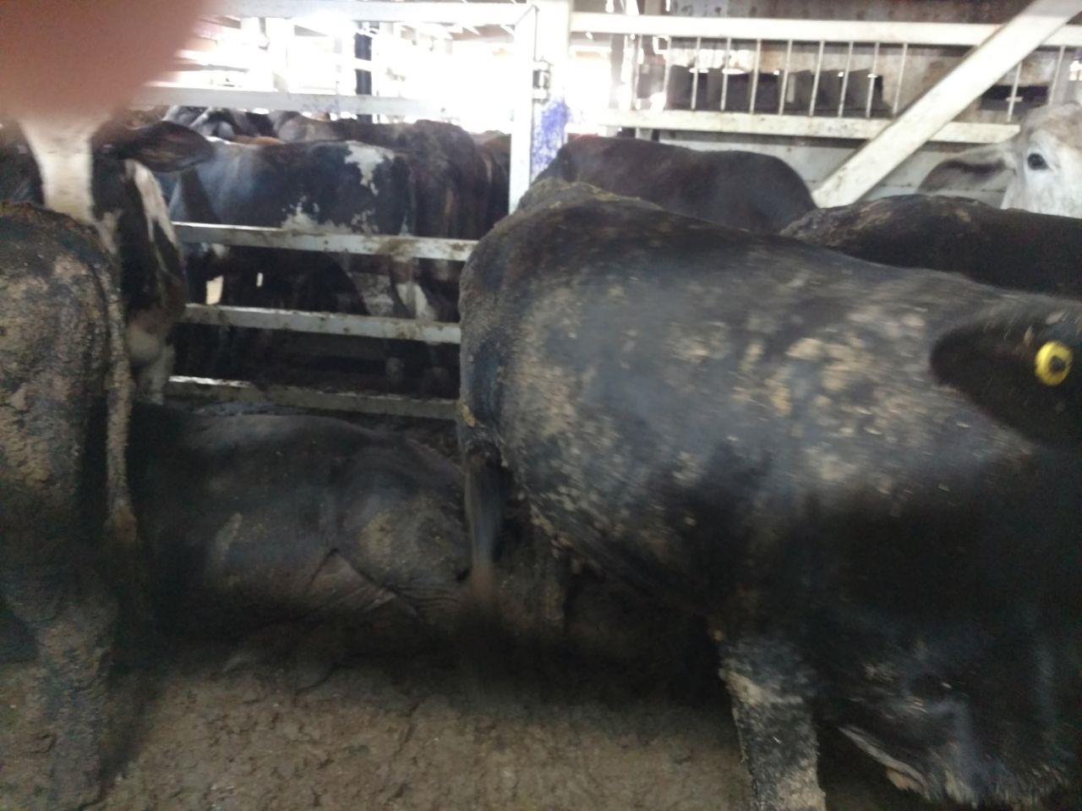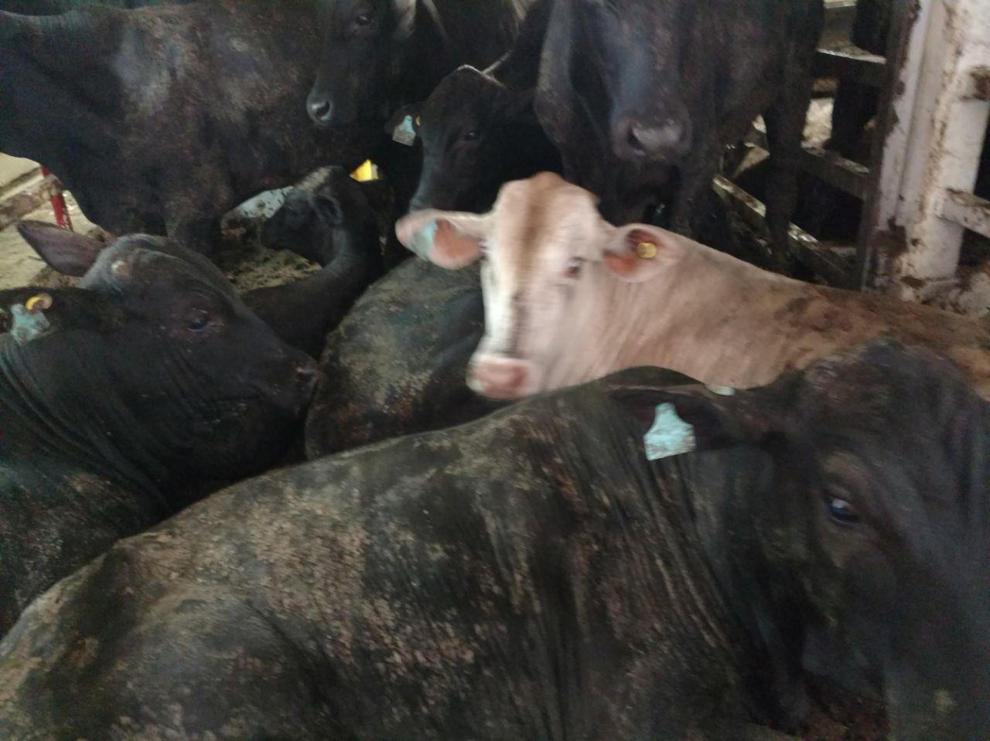
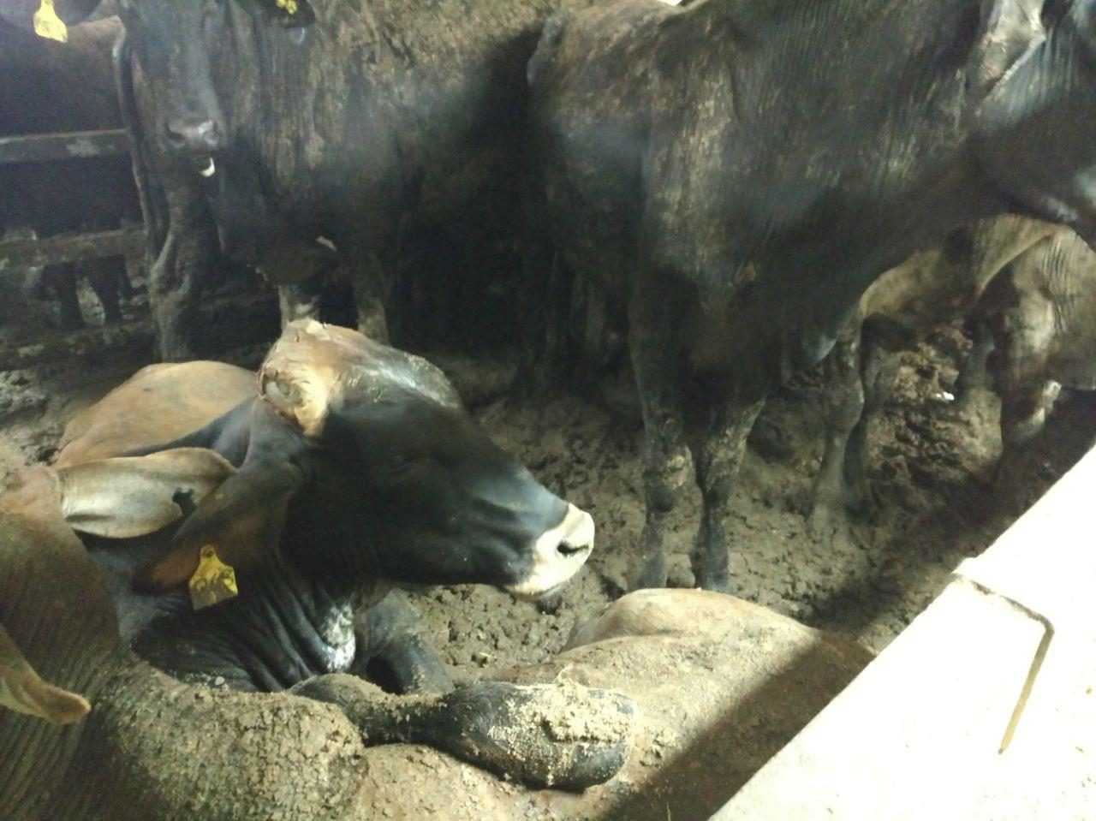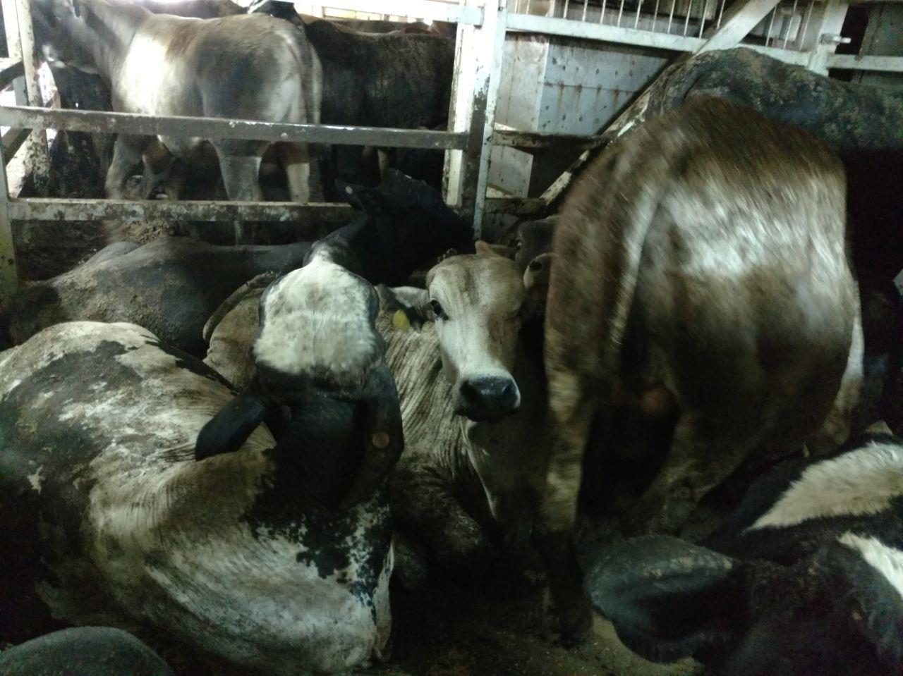
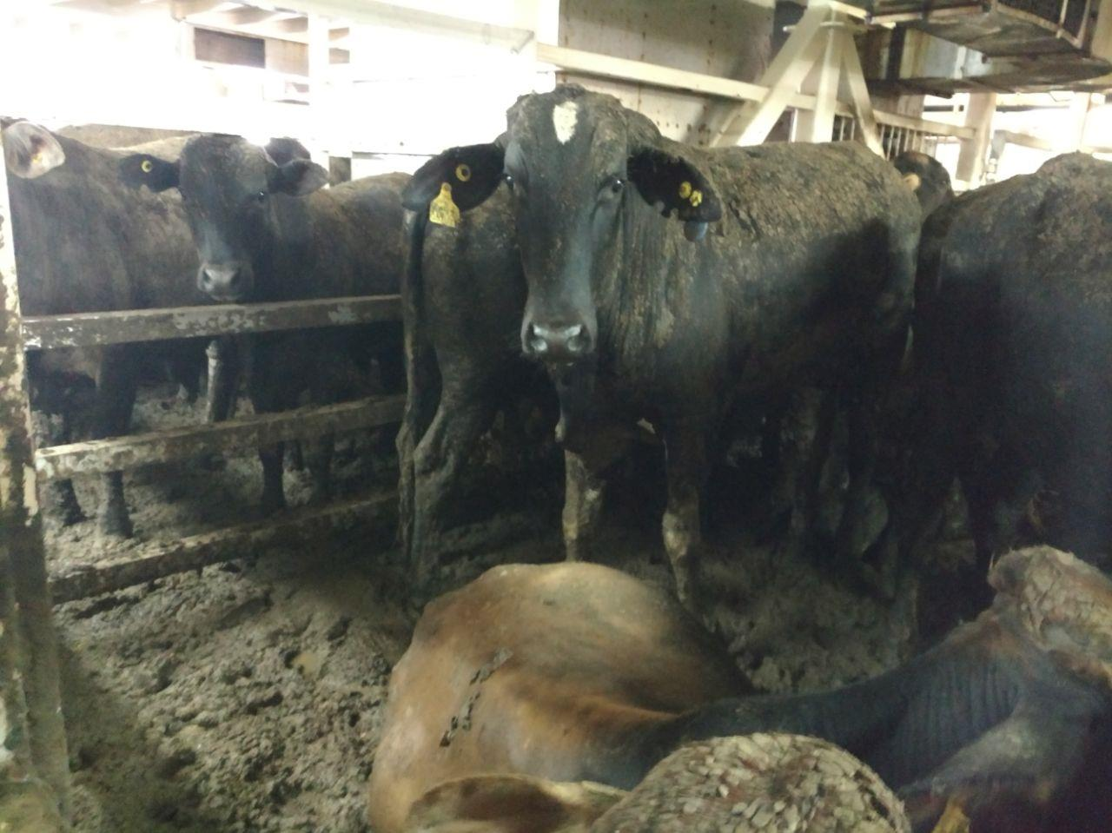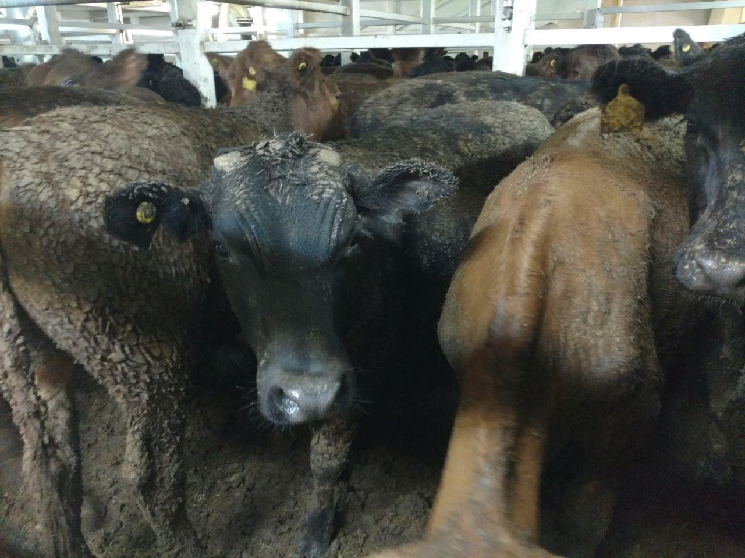
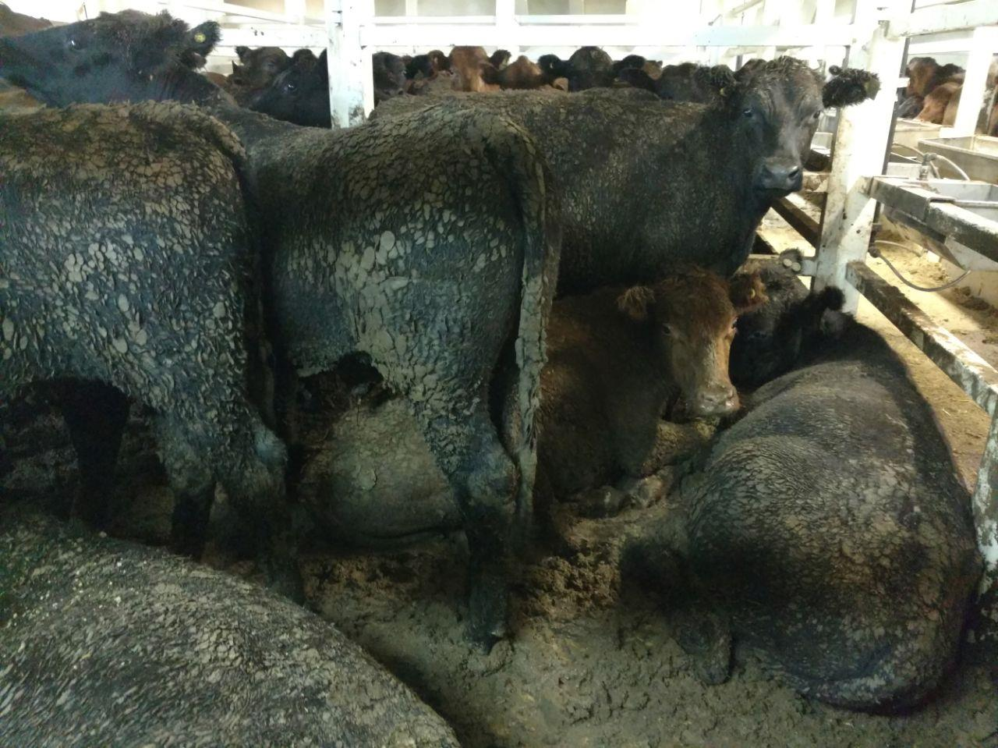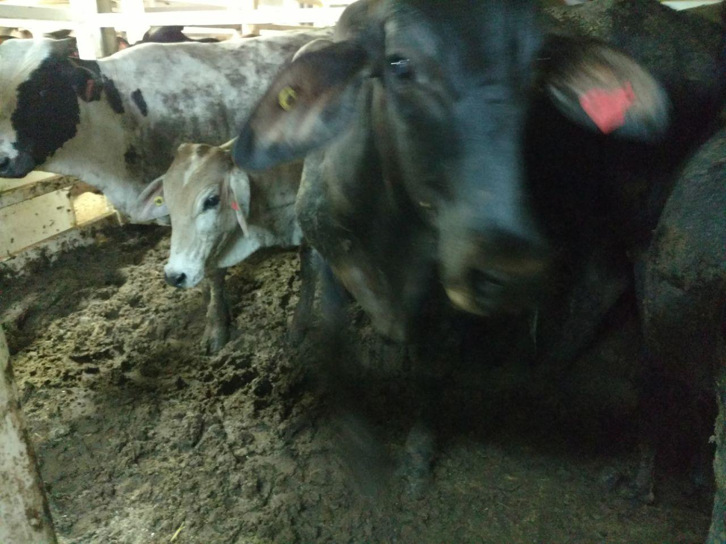
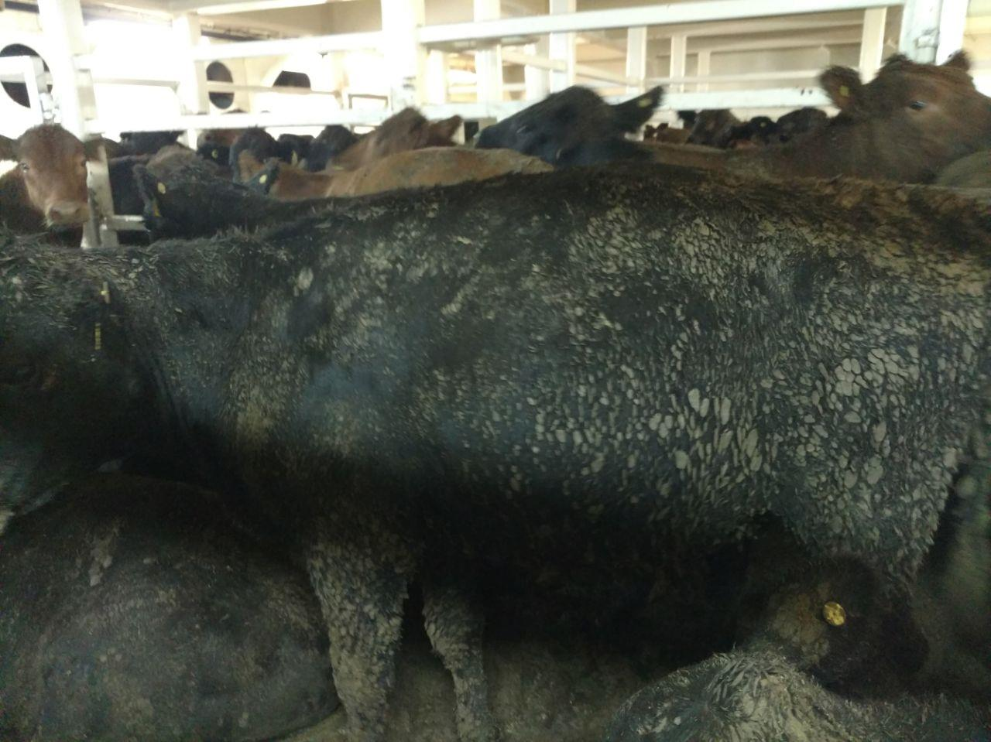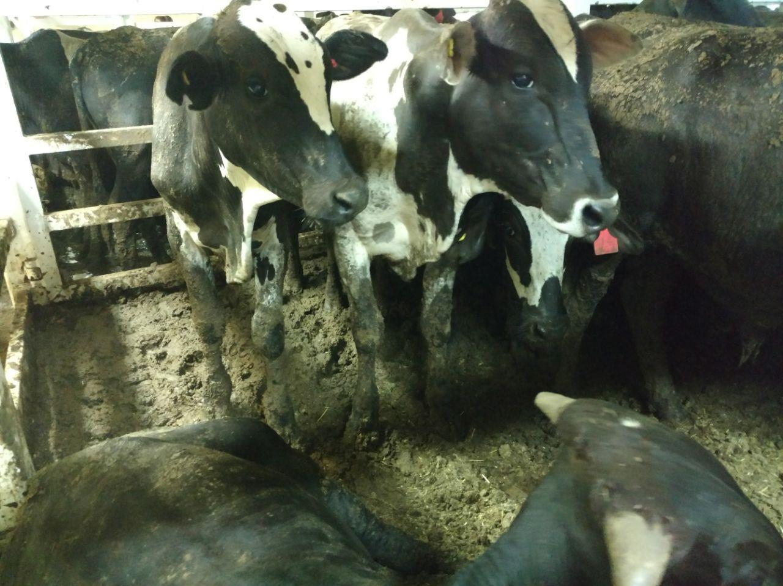
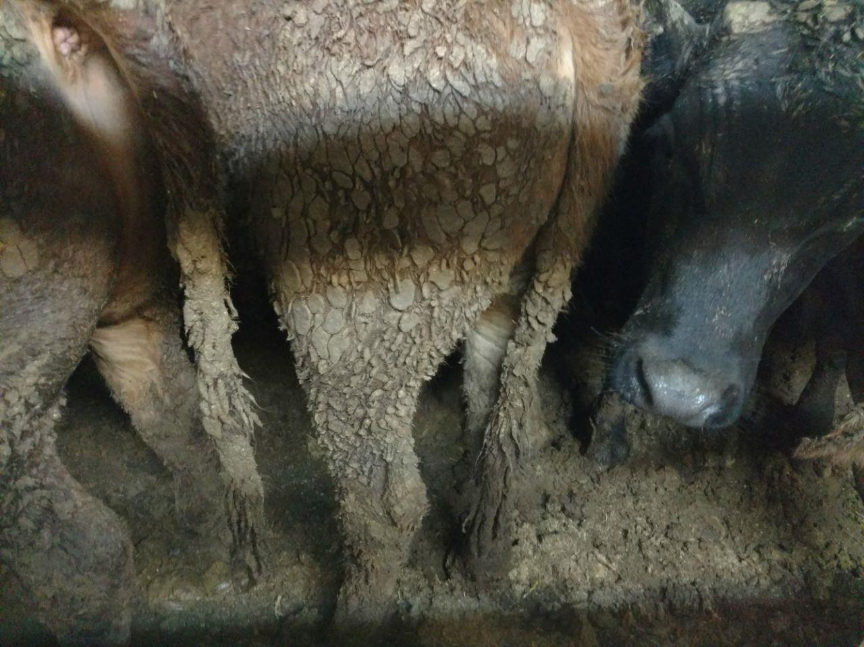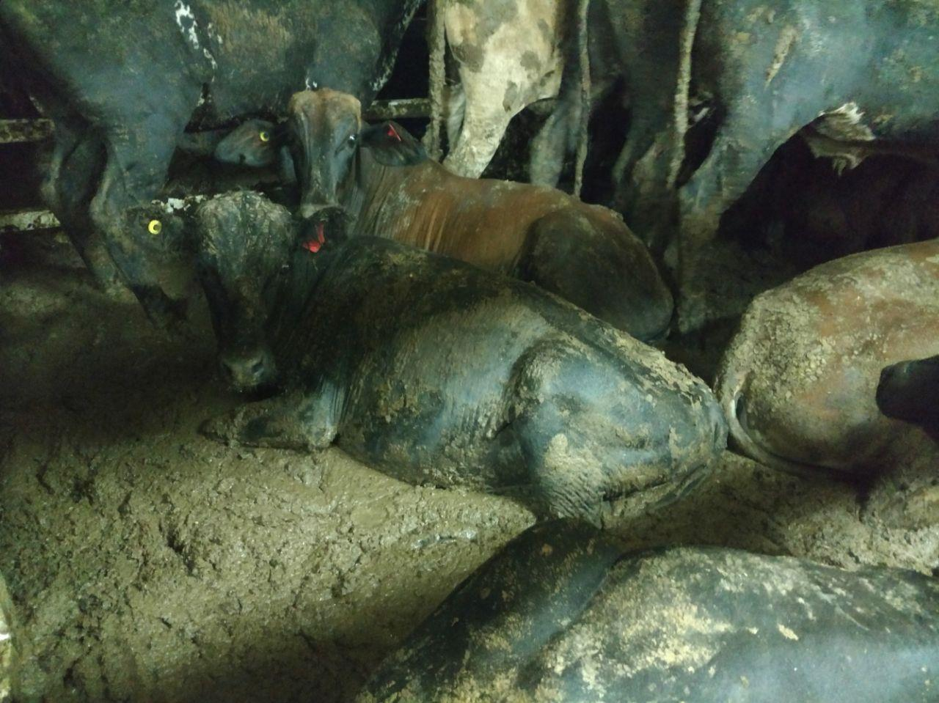
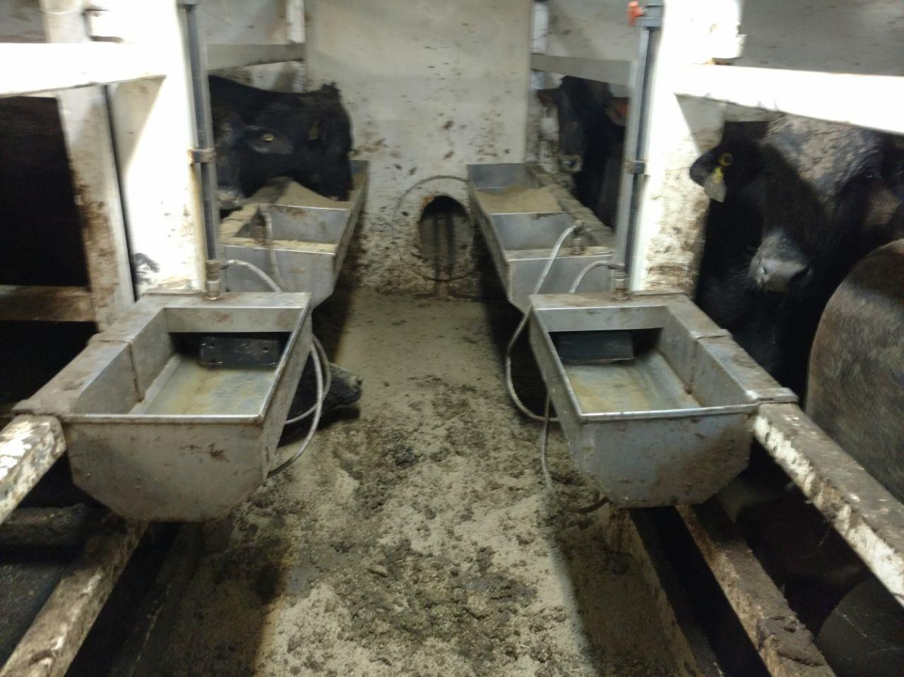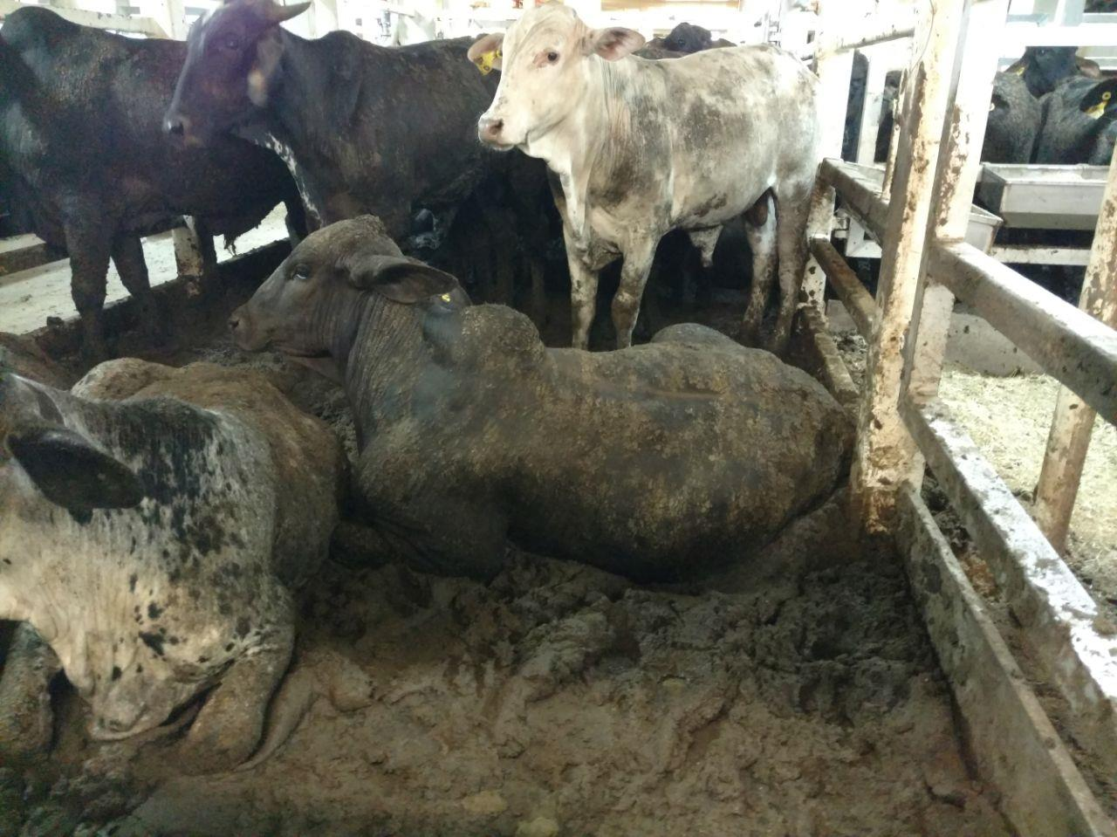
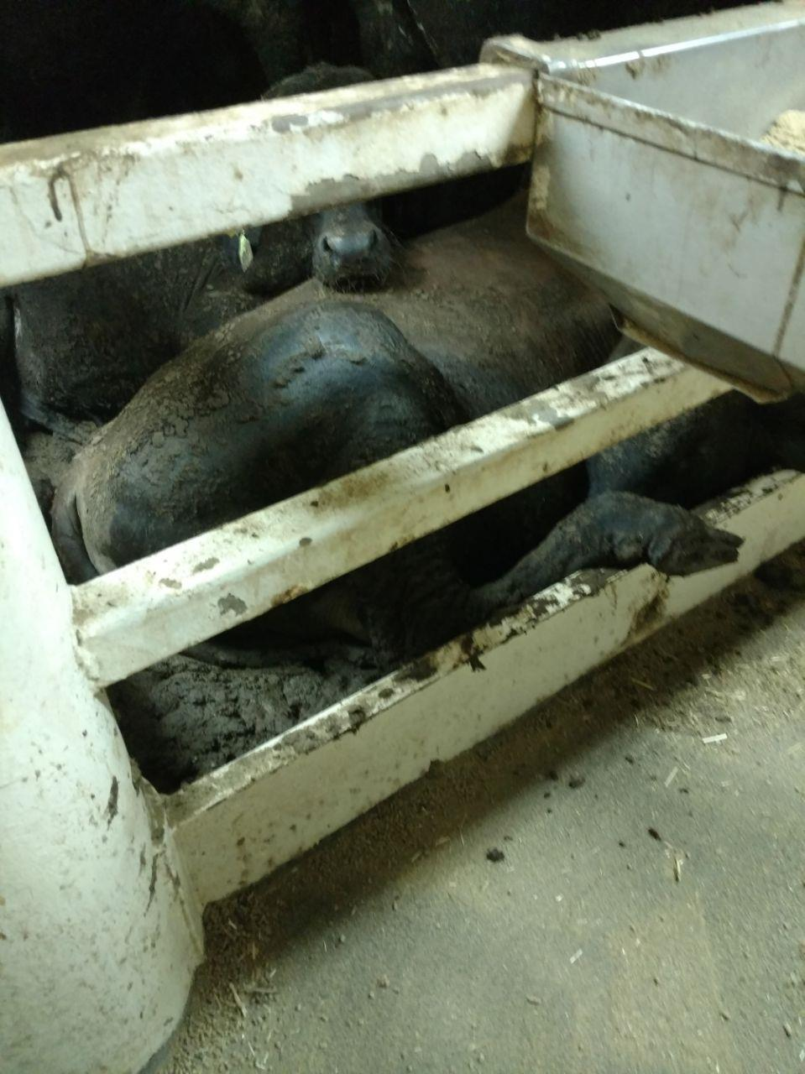
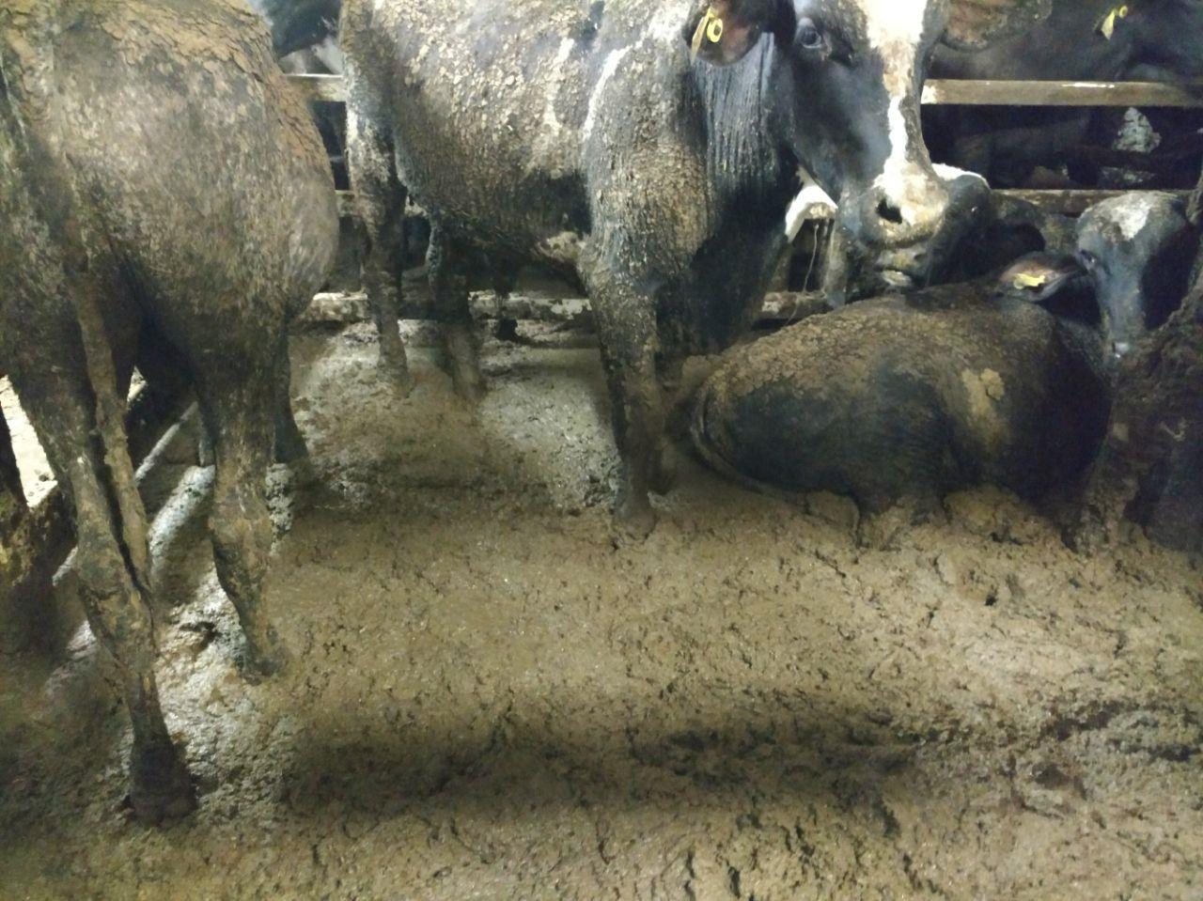
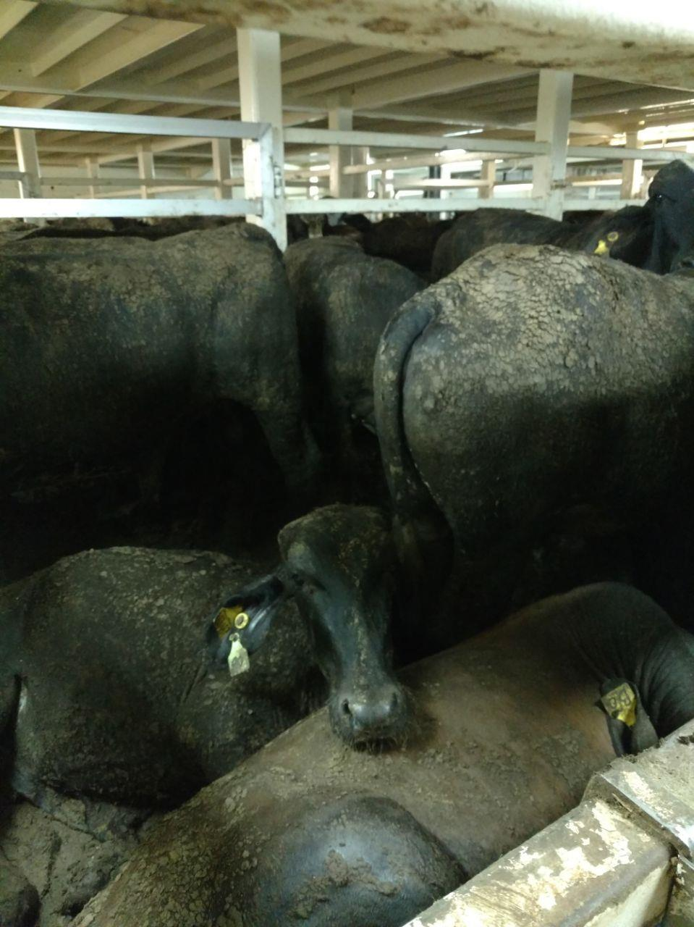
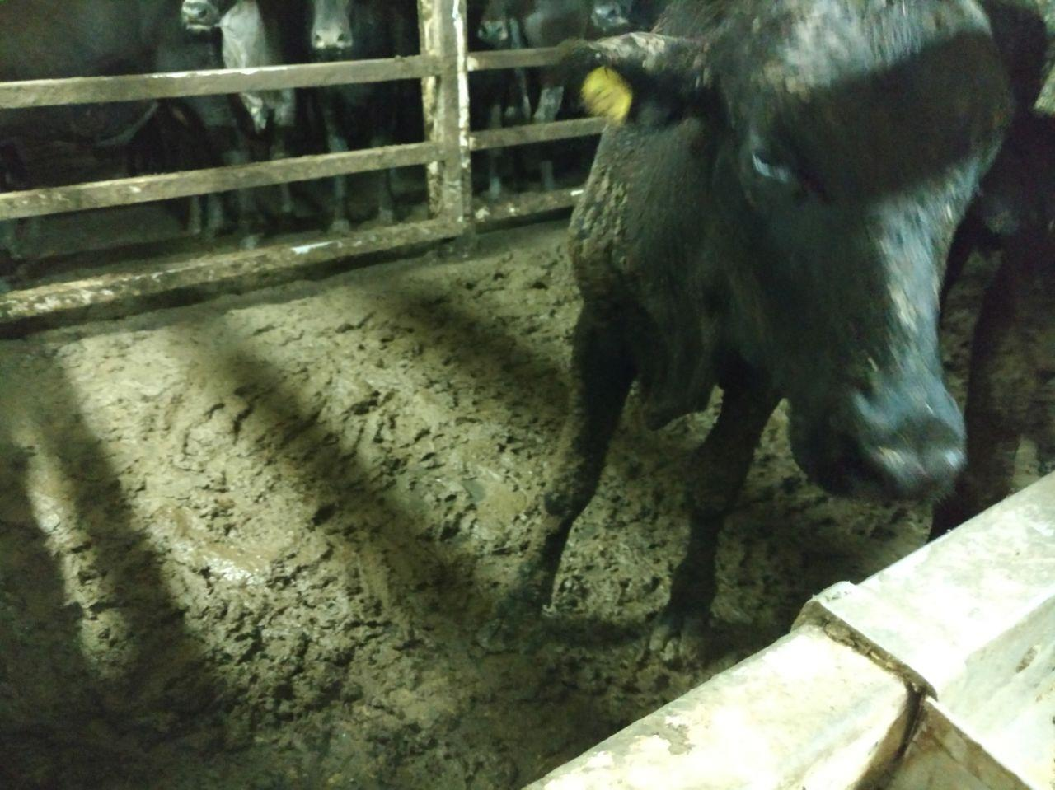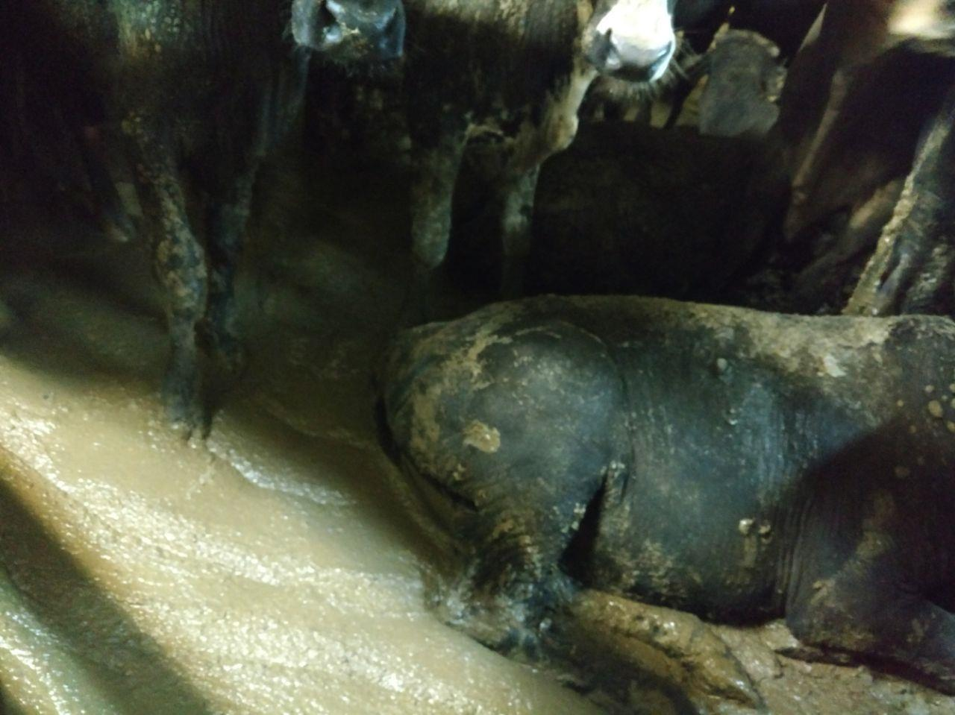
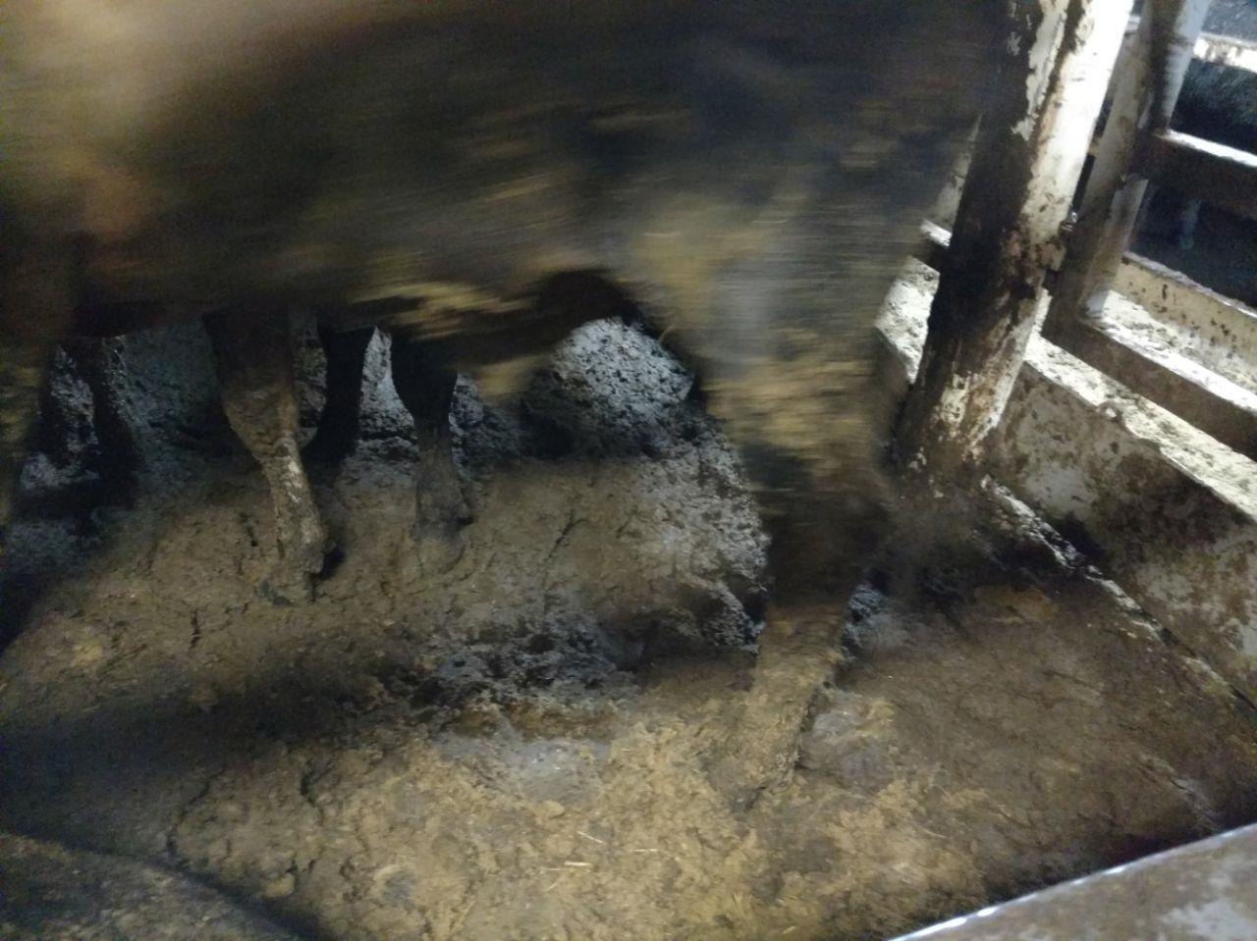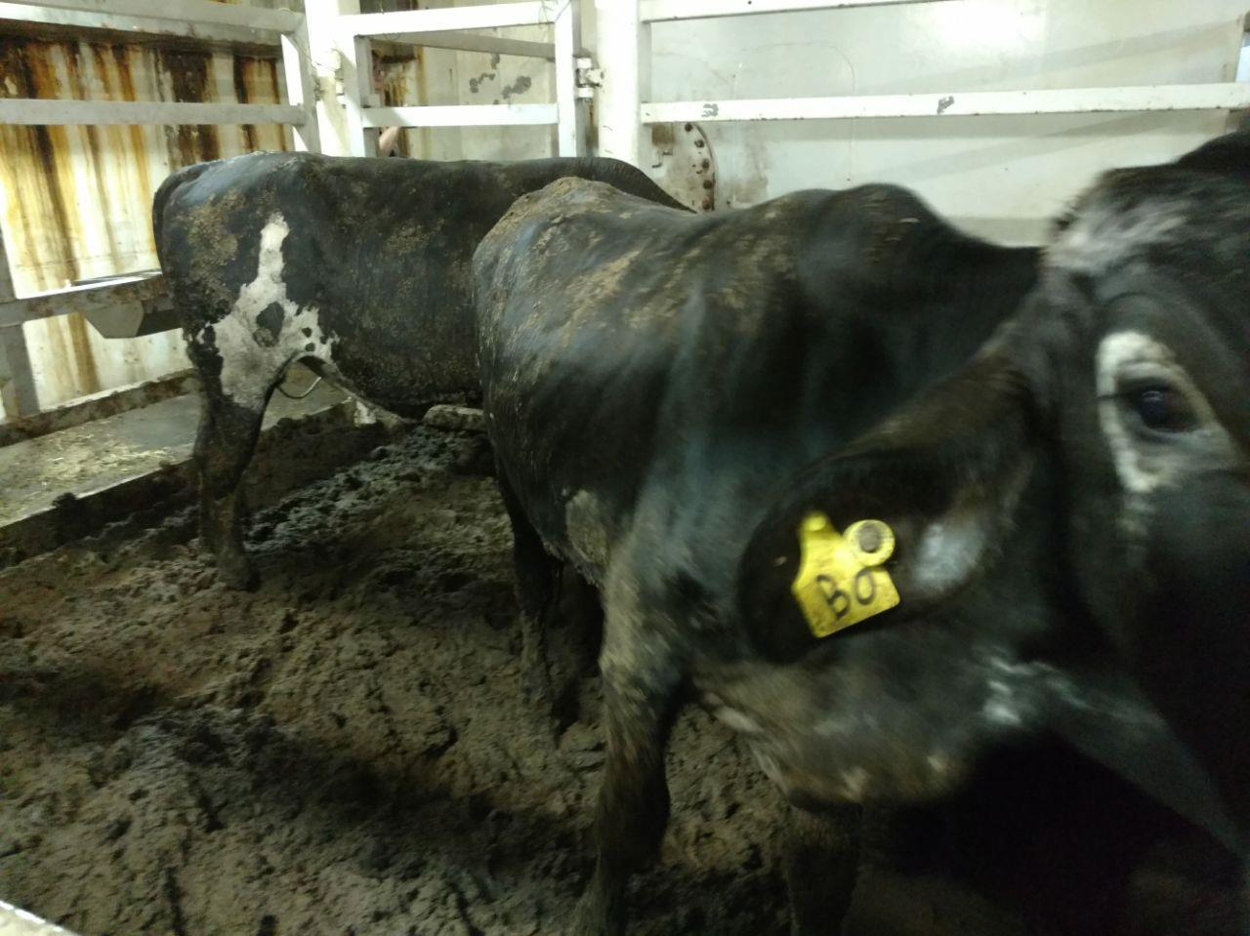
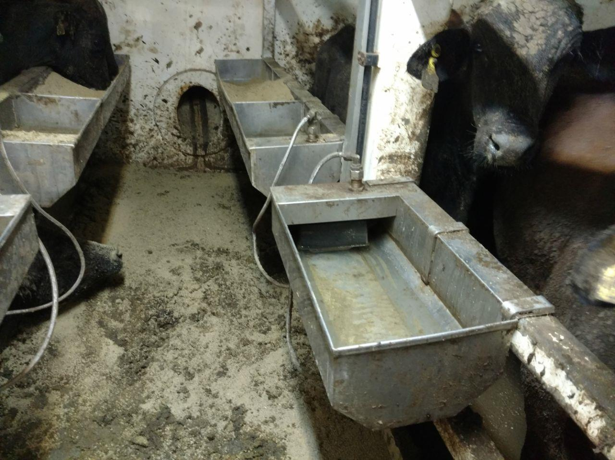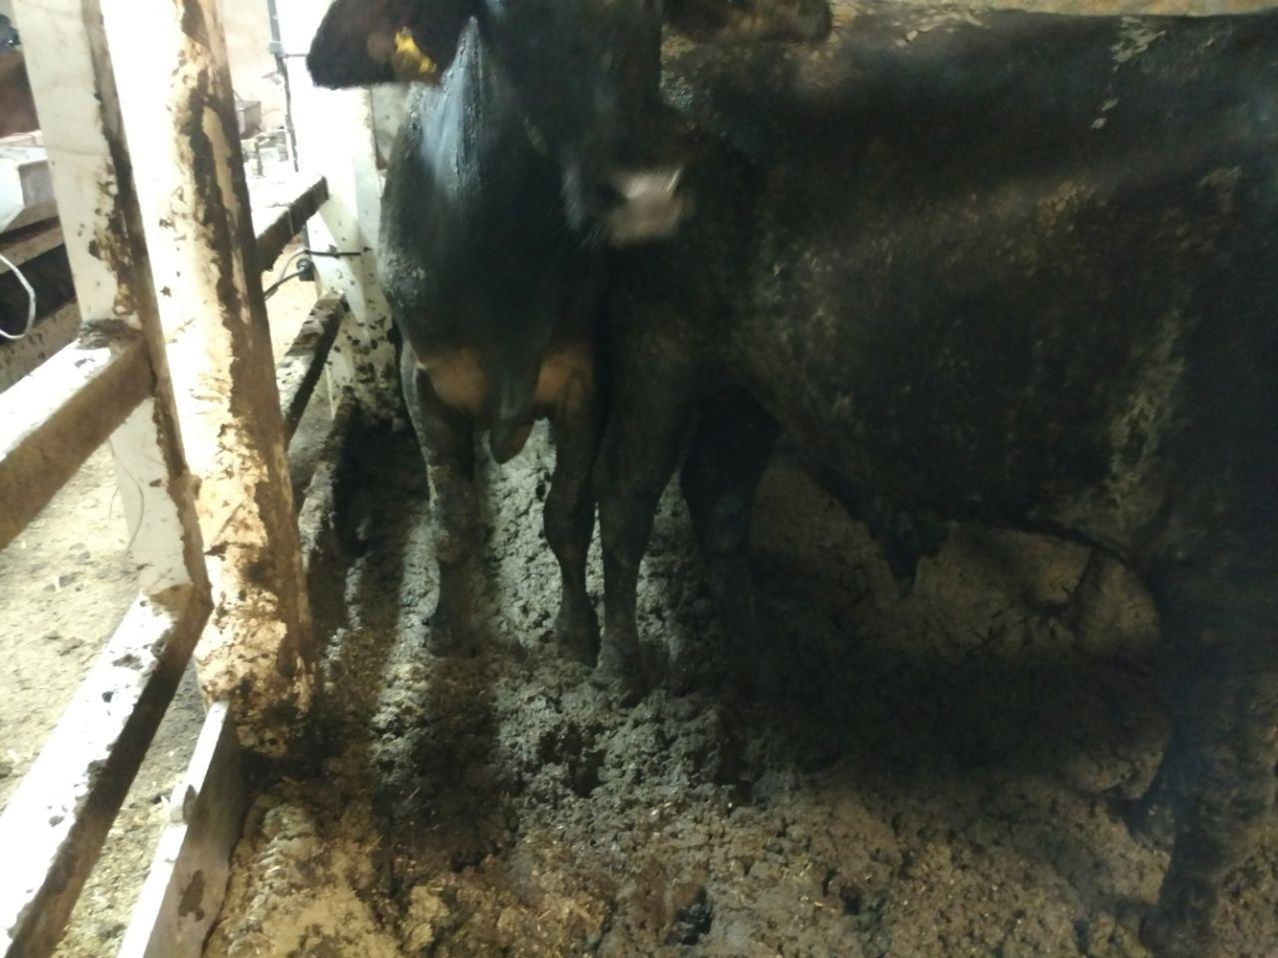
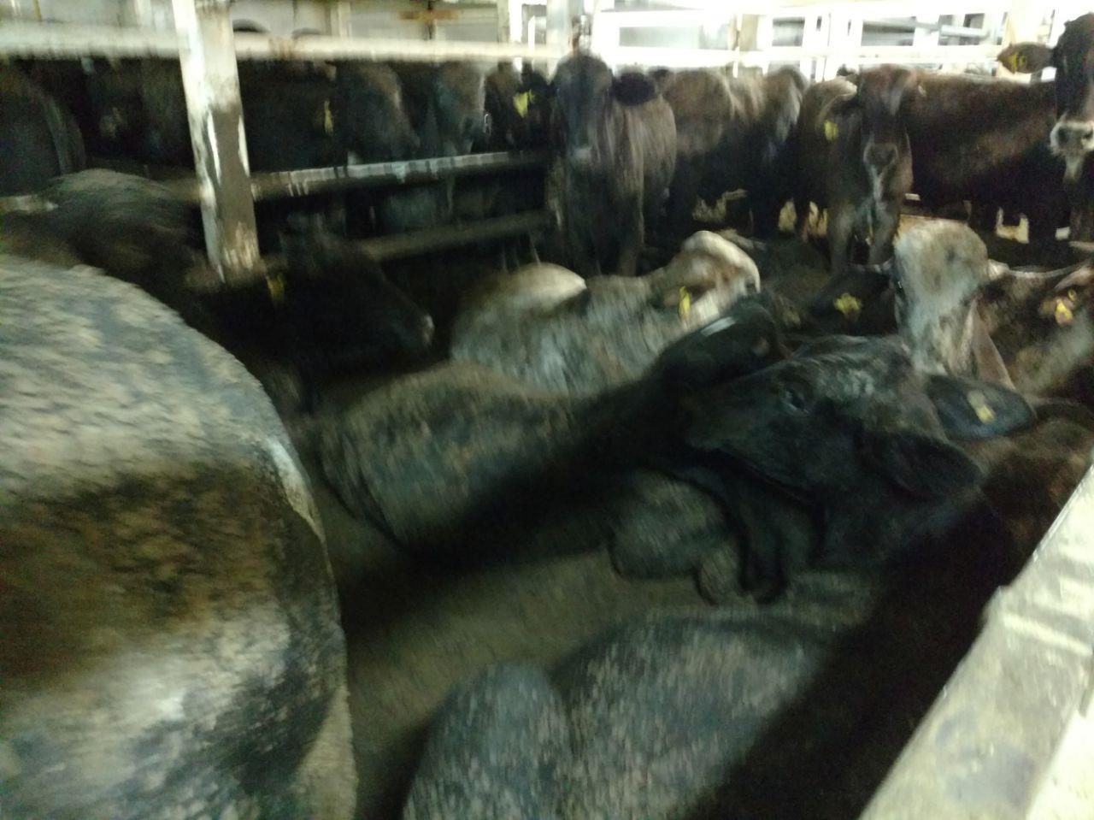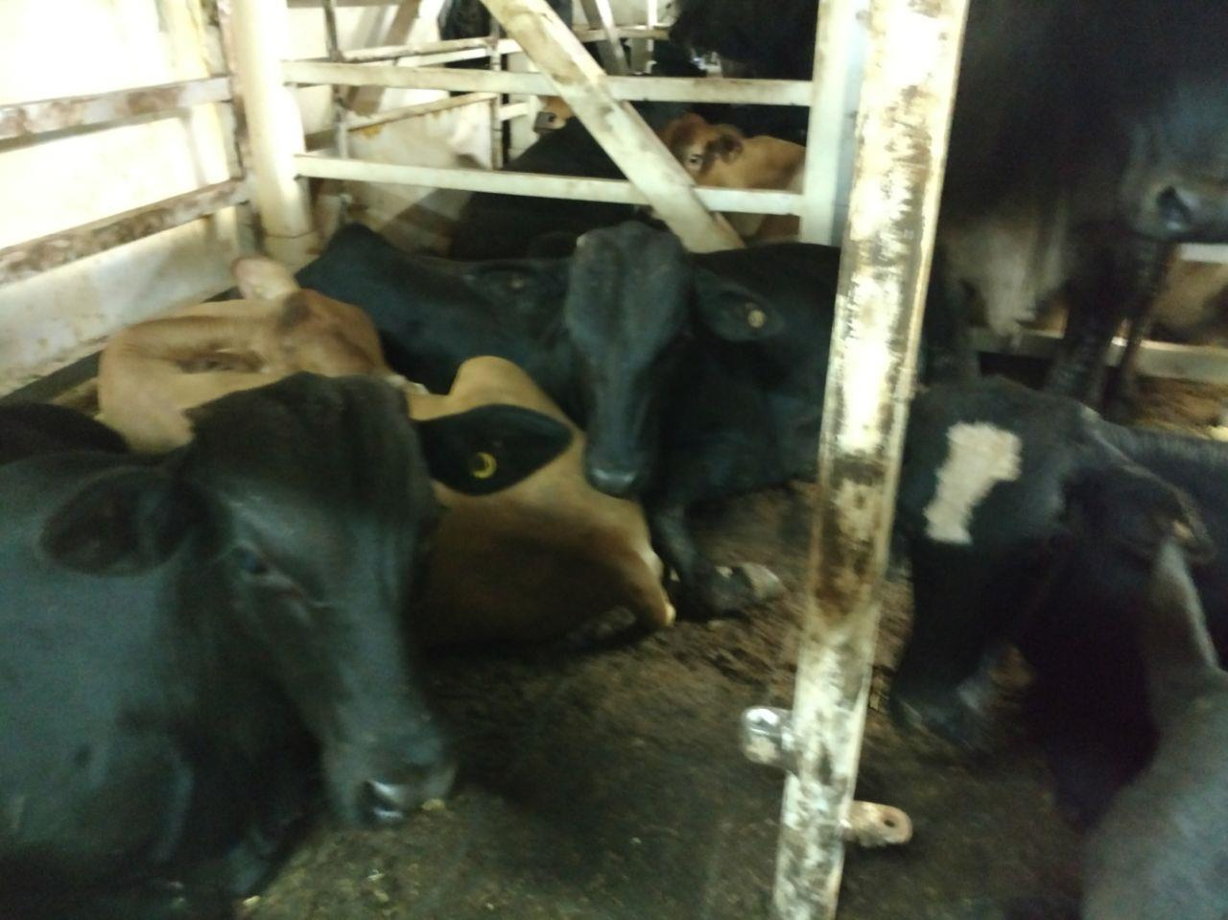
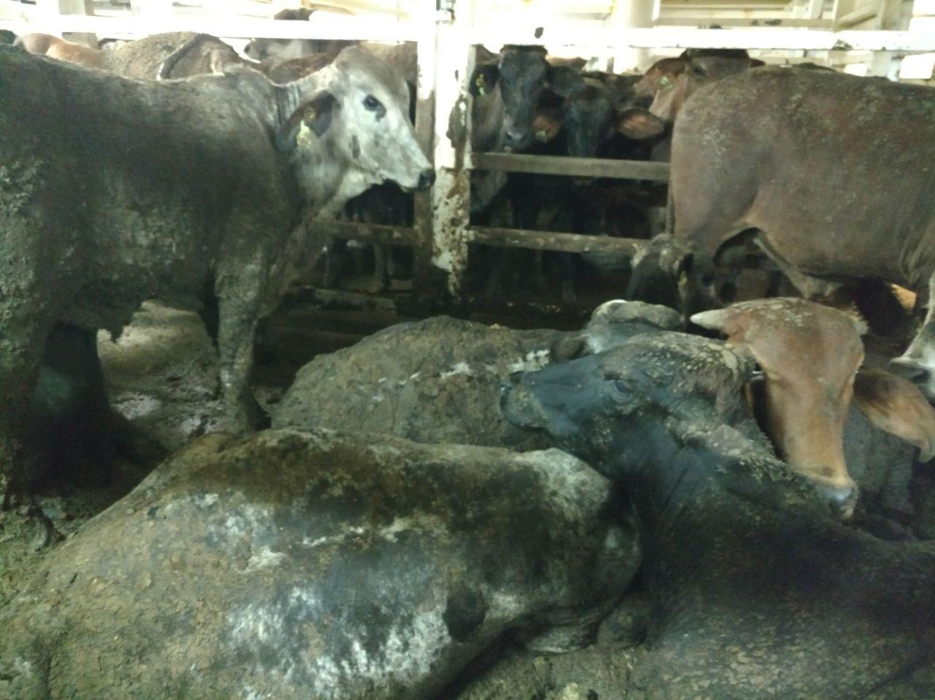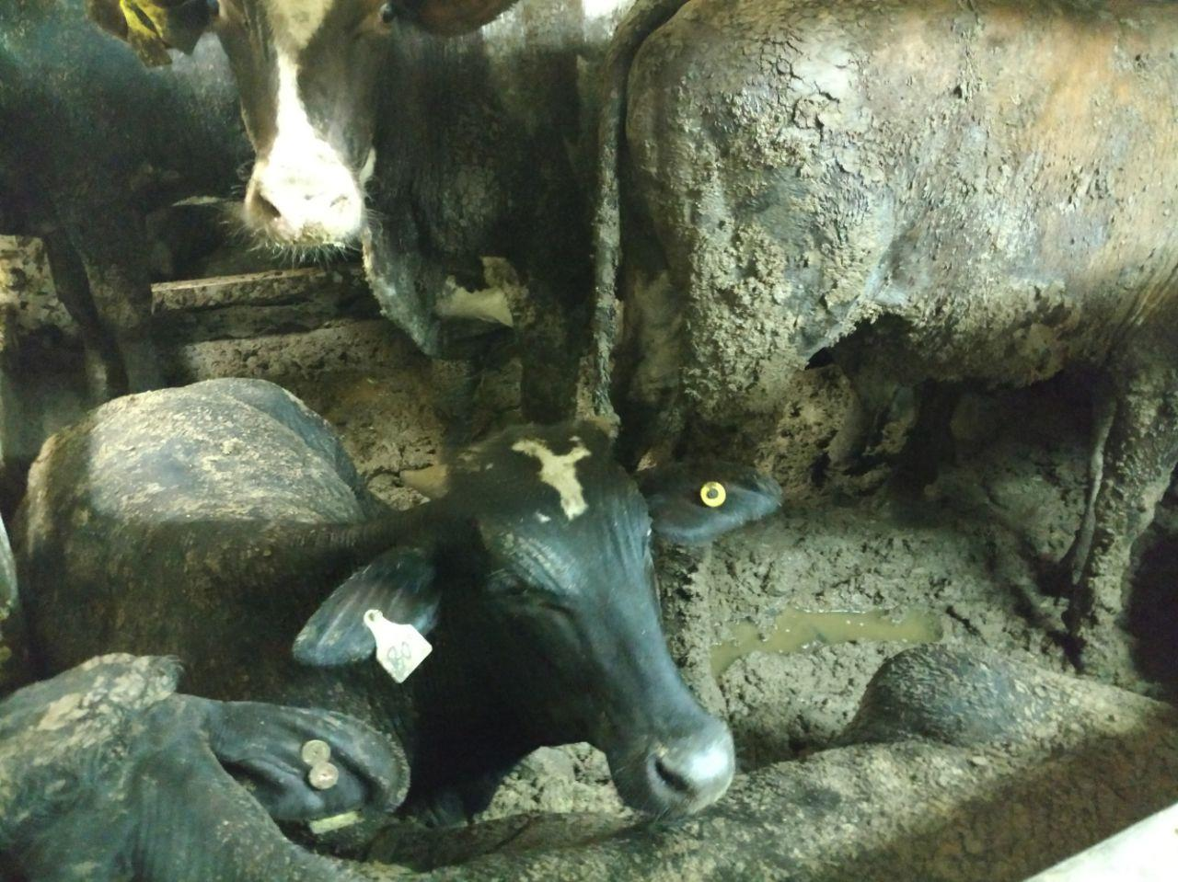
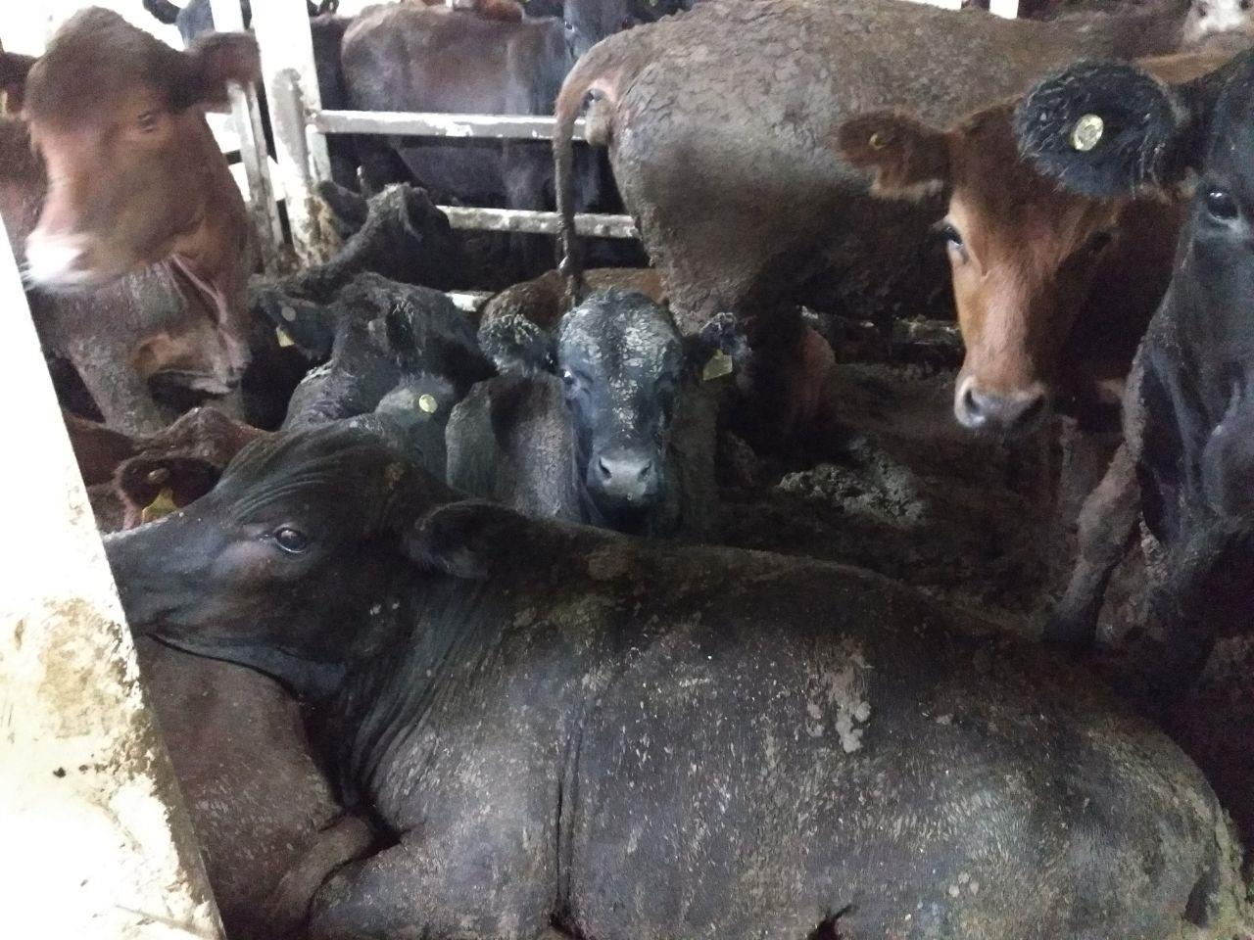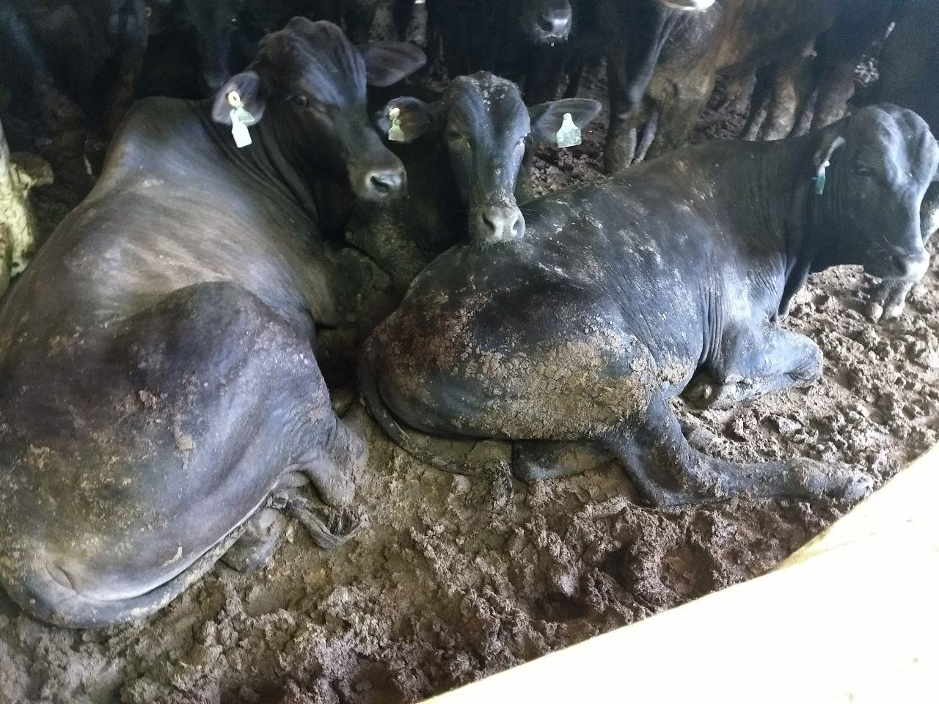
Device for grinding the animals victims of casualties on board (‘grease area’).
